 | 

MODEL 35” and 39” SNACK

GLASS FRONT MERCHANDISER
ILLUSTRATED PARTS MANUAL

LOO72 REV. H
 | AUTOMATED MERCHANDISING SYSTEMS INC.  255 WEST BURR BLVD.  KEARNEYSVILLE, WV 25430  304-725-6921 - Fax 304-725-6983  info@amsvendors.com  www.amsvendors.com | INTERNATIONAL A.M.S. S DE RL DE CV  KM. 9 CARR. AL CASTILLO NO. 8200  MPIO. DE EL SALTO, JAL. MEXICO 45680  5233-3-6-88-07-17 - Fax 5233-3-6-88-13-14  servicio@amsint.com.mx  www.amsint.com.mx

Table of Contents
SECTION PAGE
INTRODUCTION
Table of Contents 3
General Introduction 4
Manual Organization 4
Merchandiser Identification 5
Numbering System for Merchandisers 6
Patent Disclosure 6
Publication Notice 7

CABINET
Cabinet Covers and Screens 8
Cabinet Left Side and Center View 10
Cabinet Right Side View 12

CHILLER OPTION
Chiller Parts – Angled View 14
Chiller Parts – Top View 16
Chiller Option - Ventilated Cabinet 18

DOOR
Door, Coin Bay 20
Door, External Parts 24
Door, Hinges, Glass and Lights 26
Door, Optional Lamps 30
Door, Sensor System and Hopper 32
Door, Trim and Finish Parts 36
POS Display 38

ELECTRICAL HARNESSES 40

HELIX AND TRAYS
Helixes 58
Tray, 1.5” Helix 60
Tray, Universal (Snack/Candy/Food) 62
Tray, High Capacity Heavy Product 66
Tray, Horizontal Can 70
GENERAL INTRODUCTION

The purpose of this manual is to give our customers a way of identifying major service parts for repair and replacement. The illustrations and parts list in this manual are for identification only. Some optional parts are also shown.

Illustrations of these major parts are keyed with our part numbers. The illustrations help identify the general design, position and orientation of these parts. The note section may also give important information.

Please refer to the section on merchandiser identification on the following pages. Without the model style and serial number it may be difficult to identify the required part.

Parts should be ordered from your distributor.

It is our intent to assist our customers with up-to-date documentation. However, this manual may not show all parts, variations or changes. Some parts may be shown out of scale. This manual is itself subject to change without notice. If any errors are found, please notify AMS so the correction can be included in later revisions. Engineering data and third party information are generally not included. The graphical data, group assembly data, parts, part assembly, parts breakout information and tabular data conveyed by this manual is proprietary and belongs to AMS, and holders without prior consent of or without knowledge of and by AMS must surrender this data immediately.

All measurements are in inches except where specified as Metric.

MANUAL ORGANIZATION

This manual is divided into general sections. Each section is further divided into the various subsections or subassemblies. These lead off with one or more illustrations showing the parts and each part is identified with a number. Note that some part numbers are for assemblies fabricated as a unit at AMS and are replaceable only as a unit. Also, other part numbers identify optional parts which may or may not have been contracted for and factory installed by AMS.

The part number in the illustration is listed with the description or title for that part. In some instances there may be multiple parts to choose from. The correct service or repair part for the style of merchandiser must be selected. A quantities column in the list indicates quantities required.

There is a note section where additional information may be found.

This manual contains additional and new information for a vendor as currently manufactured. Older revisions of this manual should be kept with older vendors.
MERCHANDISER IDENTIFICATION

When requesting service, replacement parts or technical assistance, please use the Model Number and the Serial Number, found on the Serial Plate (Refer to Figure 1) affixed to the merchandiser. The plate is usually located inside the window. The information contained on this plate is necessary to determine what parts, kits, or maintenance apply to your vendor.

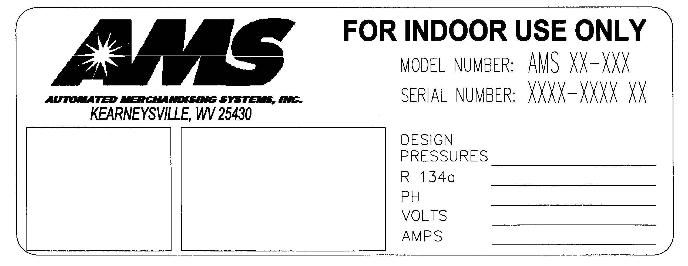
Figure 1. Example of Serial Plate

Example of Model Number Breakdown

AMS 35 – 6 418

Manufacturer Cabinet Width No. of Trays No. of Selections

Example: AMS35-6-418 means this vendor is an Automated Merchandising Systems merchandiser, 35” wide, with six (6) trays making available four hundred eighteen (418) positions for different products.

NUMBERING SYSTEM FOR MERCHANDISERS

Example of Serial Numbering System

1-0902-1156

Built Year Month Sequence

The first digit identifies where a merchandiser was manufactured. Those merchandisers built in the U.S. start with the number 1. Those merchandisers built in Mexico start with the number 2.

The next two digits identify the year of manufacture. These numbers are 09 (for 2009) and so forth.

The next two digits identify the month. The first month of the year is 01 and the last month is 12.

The last four digits identify the number assigned to each merchandiser during assembly. Numbering starts with 0000 and continues through 9999, whereupon these four digits start over at 0000.

An example of the numbering system in use is as follows:
1-0902-1156

This merchandiser was manufactured at the Kearneysville, W.V. plant in 2009, in February, and was the 1156th merchandiser manufactured.

PATENT DISCLOSURE

This merchandiser and/or certain of its components are covered by one or more of the following U.S. and international patents;

U.S. PATENTS: 6,041,962; 6,145,699; 6,202,888; 6,384,402; 6,520,373; 6,708,079; 6,794,634; 7,191,915; 7,446,302; 7,343,220, 7,446,302, 7,742,837.

CANADIAN PATENT 2,329,314.

MEXICO PATENT 230714.

PUBLICATION NOTICE

L0072, Revision H, ECN 3113, 01/24/13

It is our intent to assist our customers with up-to-date information: however, this manual may not contain all updates and is subject to revision without notice. Please contact our Service Department with your requests or comments.
COVERS AND SCREENS ILLUSTRATION

CABINET COVERS AND SCREENS PARTS LIST
ITEM | PART NO. | PART DESCRIPTION | QTY | NOTES
1 | 3000 | Screw, Sheet Metal, TEK 8-18 (1/2” Long) | 8 | Qty For One Trim
1 | 3000-06 | Screw, Sheet Metal, TEK 8-18 (3/4” Long) | 8 | Qty For Rear Trim when option P/N 21308 is Installed
2 | 3009-02 | Rivet, Pop, Steel, 1/8 (1/4” Long) | 8 | Quantities For One Cover
3 | 20185 | Tank, Rear Chiller Hole Cover | 1 | Use for Ambient (No Chiller) Option.
4 | 20187 | Wrapper, Rear Chiller Hole Cover (Black) | 1 | Use for Ambient (No Chiller) Option
4 | 20187-01 | Wrapper, Rear Chiller Hole Cover (Red) | 1 | Use for Ambient (No Chiller) Option
4 | 20187-02 | Wrapper, Rear Chiller Hole Cover (Blue) | 1 | Use for Ambient (No Chiller) Option
5 | 20275 | Trim, Rear Chiller Hole | 1
6 | 20375 | Tank - Rear Chiller Hole Cover (35) | 1 | Use for Ambient (No Chiller) Option
6 | 20185 | Tank - Rear Chiller Hole Cover (39) | 1 | Use for Ambient (No Chiller) Option
7 | 21308 | Screen, Expanded Metal, Rear Chiller Hole | 1 | Add to other rear screens.
7 | 20279 | Screen, Rear Chiller Hole (39”), 4 Mesh. | 1 | ¼” x ¼”
8 | 21481 | Wrapper– Bottom Chiller Hole Cover (35”) | 1 | Use for Ambient (No Chiller) Option
8 | 20187 | Wrapper– Bottom Chiller Hole Cover (39”) | 1 | Use for Ambient (No Chiller) Option
9 | 21469 | Screen, Bottom, Insect (35”), VER 2 Aluminum 18x16 Mesh | 1
9 | 21040 | Screen, Rear Chiller Hole, (39”) 8 Mesh (1/4” X 1/4”) | 1
9 | 20279 | Screen, Rear Chiller Hole (39”) | 1
10 | 21464 | Trim, Bottom Chiller Hole (35”) VER 2 | 1
10 | 20275 | Trim, Rear Chiller Hole (39”) | 1
General Note: The rear opening and the bottom opening are not the same size on 35” Cabinets (ECN 1770). All screen materials are fitted to trim parts, and trim parts are attached to the outside of the cabinet with screws. The combination of screens may differ. Covers to seal the cabinet are always attached flush inside and outside the cabinet (without using trim) with rivets.
CABINET LEFT SIDE AND CENTER PARTS ILLUSTRATION

CABINET LEFT SIDE AND CENTER PARTS LIST
INDEX NO. | PART NO. | PART NAME | QTY | NOTES
1 | 3000 | Sheet Metal Screw TEK #8-18 | 54
2 | 3007-06 | Screw, 5/16-18, Type F | 16 | 4 Per Leg
3 | 3017-10 | Washer, #10 SAE Flat | 2 | For Door Stop Cable (2 Places)
4 | 3018 | Sheet Metal Screw, ¼” | 3 | For Lock Assembly
5 | 3057 | Inlet, Panel Mount, IEC | 1 | Snapped Into Place at Rear of Cabinet
6 | 3060-10 | Nut, 10-32, W/Nylon Insert | 2 | For Door Stop Cable) (2 Places)
7 | 3061-06 | Screw, 10-32 x ¾ Phillips Pan Head | 2 | For Door Stop Cable (2 Places)
8 | 3067 | Spacer, .192 ID x .125 Length x 3/8 Dia. | 2 | For Door Stop Cable (2 Places)
9 | 3113 | Push Nut, 3/16” Stud | 1
10 | 20019 | Leg, Roller Bracket | 1
11 | 20121 | Leveling Leg | 5 | Cabinet To Be Leveled Using All Legs
12 | 20177 | Roller, Molded (Nylon) | 1
13 | 20291 | Cover Plate, Hinge Hole, Ver. 2 | 1 | For Top Hinge
14 | 20321 | Cover, IEC Inlet | 1 | For Shielding
15 | 20481 | Extension, Left Vertical Rail Mount | 1
16 | 20608 | Cover, Power Cord | 1 | For Power Cord Attachment to Vendor
17 | 20227 | Cable Assembly, Door Stop, Modified | 1
18 | 21122 | Assembly, Leg, Front Hinge With Thread Cover | 1
19 | 21123 | Assembly, Leg, Left Front with Thread Covers | 1
20 | 21124 | Assembly Leg, Rear with Thread Covers | 2
21 | 21250 | Shaft, Headed Roller (Zinc Plated) | 1
22 | 21839 | Rail Mount, Left Vertical VER 2 (3”) | 1
23 | 21989 | Assembly, Cabinet, (35”) | 1 | Contact AMS for your application
23 | 22071 | Assembly, Cabinet, (39”) | 1 | Contact AMS for your application
24 | 23231 | Shipping Board | 2 | 40” Long, Not Treated, (DOM)
24 | 23231-02 | Shipping Board | 2 | 38-3/8” Long, Not Treated, (DOM)
24 | 23231-01 | Shipping Board | 2 | 40” Long, Treated (ISPM 15), (EXPORT)
24 | 23231-03 | Shipping Board | 2 | 38-3/8” Long, Treated (ISPM 15), (EXPORT)
25 | 23305 | Assembly, Low Temp/Snack Cabinet Lock | 1
26 | 3827 | Power Entry Module, 230V | 1 | Europe Only
27 | 25462 | Plate, Power Entry Module, CE |  | Europe Only

CABINET RIGHT SIDE PARTS ILLUSTRATION

CABINET RIGHT SIDE PARTS LIST
INDEX NO. | PART NO. | PART NAME | QTY | NOTES
1 | 3000 | Sheet Metal Screw TEK #8-18 | 54
2 | 3006-08 | Nut, 8-32, Hex, Machine Screw | 1 | For Attaching Power Harness
3 | 3009-02 | Rivet, Pop, Steel, 1/8 x ¼ Grip Length | 2
4 | 3009-04 | Rivet, Pop, Steel, 1/8 x 3/8” Grip Length | 4 | For Attaching 21479
5 | 3017-10 | Washer, #10 SAE Flat | 2 | For Power Harness
6 | 3030 | Filter, RFI | 1 | For Filtering Electrical Noise.
7 | 3274 | Relay, Refrigeration, Single Pole | 1 | For 24V Control of Optional Chiller
8 | 3084-10 | Screw, Sems, 8-32 | 1 | For Power Harness
9 | 3133-30 | Assembly, Fuse Holder With Fuses | 1 | Use P/N 3097 3AG Fast Blow Fuse Only
10 | 3158 | Ballast, 230V 50Hz, 15 W (European) (35”) | 1
10 | 3165 | Ballast, 230V 50Hz, 18 W (European) (39”) | 1 | For Operating 3160 Florescent Lamp
12 | 3257 | Transformer, Class II, 120V / 24V | 1 | For Power
13 | 3258 | Transformer, CE, 230V / 24V | 1 | For Power
14 | 3284 | Switch, Rocker, On/Off | 1 | For 24VAC Circuit Control
15 | 20882 | Cover Plate, Column, Fixed, Right Column | 2
16 | 20211 | Cover Plate, Transformer | 1
17 | 20213 | Flange, Right Vertical | 1
18 | 20583 | Harness, Ballast European | 1 | 220V Single
19 | 20563 | Harness, Ballast Assy 2 | 1 | 110V Single
20 | 21053 | Stiffener, Right Vertical Rail Mount | 1
21 | 21479 | Plate, Fuse Holder, Socket And Power Switch Mount | 1 | Attached Inside of Rail Mount
22 | 21509 | Decal, 24V Fuse, Ver. 2 | 1
23 | 23305 | Assembly, Cabinet, (35”) | 1 | Contact AMS for your application
23 | 22071 | Assembly, Cabinet, (39”) | 1 | Contact AMS for your application
24 | 23724 | Rail Mount, Right Vertical, Snack, (35”) | 1
24 | 21476 | Rail Mount, Right Vertical, Snack, (39”) | 1

CHILLER PARTS ILLUSTRATION – ANGLED VIEW

CHILLER PARTS LIST – ANGLED VIEW
ITEM | PART NO | PART DESCRIPTION | QTY | NOTES
1 | 3000 | Sheet Metal Screw TEK #8-18 | 46
2 | 3018-06 | Screws, ¼ x ¾, Self Tapping, Hex Head | 2 | For Attaching To Tank Walls
3 | 3018-08 | Screws, ¼ x 1, Self Tapping, Hex Head | 6 | For Attaching To Tank Floor
4 | 3106 | Evaporator Fan/Motor Assembly, 220V, 50Hz, 1 Phase | 1 | Note Voltage!
5 | 3107 | Evaporator Fan/Motor Assembly, 110V, 60Hz, 1 Phase | 1 | Note Voltage!
6 | 21987 | Evaporator Cover Plate (35”) | 1
6 | 20316 | Evaporator Cover Plate (39”) | 1
7 | 20317 | Evaporator Plenum | 1
8 | 25633 | Assembly, 1/4, Chiller, 120V | 1 | See Note
8 | 20531 | Assembly, 1/4, Chiller, 220V | 1 | See Note
9 | 23304 | Assembly, Chiller Housing, English (35”) | 1 | Housing must seal against Cabinet As Shown
9 | 23304-01 | Assembly, Chiller Housing, Spanish (35”) | 1 | Housing must seal against Cabinet As Shown
9 | 22105 | Assembly, Chiller Housing, English (39”) | 1 | Housing must seal against Cabinet As Shown.  Supplied with access Door.
9 | 22105-01 | Assembly, Chiller Housing, Spanish (39”) | 1
10 | 21424 | Bracket, Temperature Sensor, Sensit II | 1
11 | 23305 | Assembly, Cabinet, (35”) | 1 | Contact AMS For Your Application
11 | 22071 | Assembly, Cabinet, (39”) | 1 | Contact AMS For Your Application
12 | 21991 | Evaporator Mounting Panel, Stamped Drain Pan | 1 | For Stamped Pan Assemblies
13 | 21992 | Assembly, Stamped Evaporator Drain Pan | 1 | Use with 21991, Evaporator Mounting Panel

NOTE: Chiller assemblies are charged with refrigerant and are replaceable only as an assembly. The refrigeration system is pressurized and sealed at the factory. Puncturing or cutting any component in the system will cause refrigerant gas and liquid to be propelled out of the system, creating an immediate physical hazard. Use caution to avoid accidentally opening the refrigerant system.
It should also be noted that releasing refrigerant to the atmosphere is a federal crime and is punishable by law. Any service work requiring the system to be opened must be performed by a licensed technician using certified recovery equipment. Unauthorized service to the sealed refrigerant system may void the warranty.

Ambient snack merchandisers have no chillers or chiller parts. Ventilated merchandisers have a forced air system without any chiller.
CHILLER PARTS ILLUSTRATION – TOP VIEW

CHILLER PARTS LIST – TOP VIEW
ITEM | PART NO | PART DESCRIPTION | QTY | NOTES (See Note A Below)
1 | 3065 | Fan, Condenser Assembly, 220V, 50Hz, 1 Phase | 1 | Note Voltage!
1 | 3108 | Fan, Condenser Assembly, 110V, 60Hz, 1 Phase | 1 | Note Voltage!
2 | 3093 | Sponge (Condenser Drain Pan) | 4
3 | 20144 | Refrigeration Harness | 1 | Use With Both 110V or 220V Systems
4 | 25633 | Assembly, 1/4 H.P. Chiller, 120V, VER 2, AMS (WV) | 1 | See Note
4 | 20531 | Assembly, 1/4 H.P. Chiller, 240V, VER 2, AMS (WV) | 1 | See Note
5 | 21991 | Evaporator Mounting Panel, Stamped Drain Pan | 1 | Used with Stamped Pan Assemblies
6 | 21992 | Assembly, Stamped Evaporator Drain Pan | 1 | Use with 21991, Evaporator Mounting Panel
7 | 22048 | Condenser Drain Pan, Formed | 1 | Stamped Fabrication
NOTE A: Chiller assemblies are charged with refrigerant and are replaceable only as an assembly. . The refrigeration system is pressurized and sealed at the factory. Puncturing or cutting any component in the system will cause refrigerant gas and liquid to be propelled out of the system, creating an immediate physical hazard. Use caution to avoid accidentally opening the refrigerant system.
It should also be noted that releasing refrigerant to the atmosphere is a federal crime and is punishable by law. Any service work requiring the system to be opened must be performed by a licensed technician using certified recovery equipment. Unauthorized service to the sealed refrigerant system may void the warranty.

Ambient snack merchandisers have no chillers or chiller parts. Ventilated merchandisers have a forced air system without any chiller.
CHILLER OPTION - VENTILATED CABINET ILLUSTRATION

CHILLER OPTION - VENTILATED CABINET PARTS LIST
ITEM | PART NO. | PART DESCRIPTION | QTY | NOTES
1 | 3000 | Screw, Sheet Metal, TEK 8-18 | 16 | Qty For Two Trim Parts
1 | 3000 | Screw, Sheet Metal, TEK 8-18 | 12 | Qty For Ventilator Assembly
2 | 3000-06 | Screw, Sheet Metal, TEK 8-18 | 8 | Replace Item 1 For Rear Trim only When Option P/N 21308 is Installed
3 | 20275 | Trim, Chiller Hole | 1
4 | 21040 | Screen, Rear Chiller Hole, 8 Mesh (1/4” X 1/4”) | 1
4 | 21308 | Screen, Expanded Metal, Rear Chiller Hole | 1 | Add to other rear screens.
5 | 21463 | Screen, Bottom Chiller Hole, (35”) 8 Mesh, VER 2 | 1
5 | 20279 | Screen, Rear Chiller Hole | 1
6 | 21464 | Trim, Bottom Chiller Hole (35”) VER 2 | 1
6 | 20275 | Trim, Chiller Hole (39”) | 1
7 | 21989 | Assembly, Cabinet, (35”) | 1 | Tank is Inside, Wrapper is Outside
7 | 22071 | Assembly, Cabinet, (39”) | 1
8 | 23303 | Assembly, Ventilator, Ver. 3, (35”) 110V | 1
8 | 22080 | Assembly, Ventilator, Ver. 4, (39”) 110V | 1
General Note: The rear opening and the bottom opening are not the same size on 35” Cabinets (ECN 1770). All screen materials are fitted to trim parts, and trim parts are attached to the outside of the cabinet with screws. The combination of screens may differ. Covers are not used. Cabinet is shown without any other parts.

Ambient snack merchandisers have no chillers or chiller parts. Chiller units provide refrigeration in the cabinet.

DOOR COIN BAY ILLUSTRATION

DOOR COIN BAY PARTS LIST
INDEX NO. | PART NO. | PART NAME | QTY | NOTE
1 | 3000 | Screw, Sheet Metal TEK 8-18 | 18
2 | 3005-04 | Carriage Bolt, #10-24,1/2" | 5
3 | 3006-08 | Nut, Hex, Machine Screw, #8-32 | 8 | 4 per DBV Opening
4 | 3006-10 | Nut, Hex, Machine Screw, #10-24 | 5
5 | 3009-04 | Rivet, Steel, 1/8", Black, Grip Length 1/4" | 12
6 | 3017-06 | Washer, Flat Steel, SAE Std., #6 Screw 5/32 | 10
7 | 3017-10 | Washer, Flat Steel, SAE Std., #10 Screw 7/32 X ½ | 2
8 | 3037-1 | PC Board Support (3/16") | 6 | For Control Board
9 | 3038 | Rivet, Nylon, Trim | 2 | Hold Door Closed
10 | 20081-01 | Scavenger Button, Blk | 1
11 | 24631 | Assy., Coin Chute, Upper | 1
12 | 24641 | Scavenger Guide, Epoch | 1
13 | 23373 | Assembly, Plastic Coin Cup | 1
14 | 24961 | Coin Box Bulkhead | 1
15 | 20181 | DBV Cover Plate | 2 | Flat Steel Plate, 1 per DBV Opening
16 | 24962 | Assembly, Coin Chute, Lower | 1
17 | 24642 | Bracket, Pushbutton Alignment, Epoch | 1
18 | 24613 | Assembly, Coin Box | 1
19 | 20706 | Door Stiffener, Upper, Without Fuse And Switch | 1
19 | 20709 | Door Stiffener, Upper, Locking, W/O Fuse And Switch | 1 | Not Shown
20 | 20707 | Door Stiffener, Bottom With Switch | 1
21 | 20752 | Assembly, Coin Door, Upper (51") | 1
22 | 25655 | Control Board, Sensit 3 | 1
23 | 24608 | Mounting Panel, Changer, Multi-Use | 1
24 | 24739 | Assembly, Display, VER 3, Escutcheon, Sensit II | 1 | Contains display board
25 | 24625 | Assembly, Scavenger System, VER. 3, ADA Escutcheon, Epoch | 1

26 | 25222 | Assy., Foamed Door, Snack, Epoch (35”) | 1 | Contact AMS for your application.
26 | 25106 | Assy., Foamed Door, Snack, Epoch-ADA (35”) | 1 | Contact AMS for your application.
26 | 25220 | Assy., Foamed Door, Snack, Epoch (39”) | 1 | Contact AMS for your application.
26 | 25083 | Assy., Foamed Door, Snack, Epoch-ADA (39”) | 1 | Contact AMS for your application.

THIS PAGE INTENTIONALLY LEFT BLANK

DOOR, EXTERNAL PARTS ILLUSTRATION

DOOR, EXTERNAL PARTS LIST
ITEM | PART NO. | PART NAME | QTY. | NOTE
1 | 3005-04 | Carriage Bolt, #10-24, 1/2” Long | 2 | For Securing T-handle
2 | 3006-10 | Nut, Hex, Machine Screw, #10-24 | 2 | For Securing T-handle
3 | 3011 | Self Threading Nut, ¼” Stud | 8 | For Securing Escutcheon
4 | 3289-02 | Screw, Type B, #8, Pan Head, Phillips #2 | 2 | For Securing Keypad
5 | 20130 | T-Lock Assembly | 1
6 | 20131 | Lockset And Keys | 1 | Contact AMS for your application
7 | 20344 | Assembly, DBV Mounting Bezel | 2
8 | 23930 | Decal, Guaranteed Delivery | 1 | Optional Item
9 | 22175 | Lens, Escutcheon, GFM, VER 2 | 1
10 | 24616 | Escutcheon, Plastic, Epoch | 1
 | 24623 | Escutcheon/Keypad Assy |  | Includes Escutcheon, Lighted Keypad & Buttons and Display Lens
11 | 22177 | Button, 0.90” Dia. Round, Escutcheon | 12 | 12 Key Escutcheon
12 | 25688 | Assembly, Lighted Keypad | 1 | 12 Key Escutcheon
13 | 22184-01 | DBV Cover Panel, Gray | 2 | Optional Item
14 | 25222 | Assy., Foamed Door, Snack, Epoch (35”) | 1 | Contact AMS for your application.
14 | 25106 | Assy., Foamed Door, Snack, Epoch-ADA (35”) | 1 | Contact AMS for your application.
14 | 25220 | Assy., Foamed Door, Snack, Epoch (39”) | 1 | Contact AMS for your application.
14 | 25083 | Assy., Foamed Door, Snack, Epoch-ADA (39”) | 1 | Contact AMS for your application.
15 | 21703 | Assy., Top Hinge, 3/16” | 1
16 | 21704 | Assy., Bottom Hinge, 3/16” | 1
17 | 24746 | Led Driver, Keypad

DOOR HINGES, GLASS AND LIGHTING LAMPS ILLUSTRATION

DOOR HINGES, GLASS AND LIGHTING LAMPS PARTS LIST
ITEM NO. | PART NO. | PART DESCRIPTION | QTY. | NOTE
1 | 3000 | Screw, TEK 8-18 | 14
2 | 3004-06 | Carriage Bolt, ¼-20, ¾” | 4
3 | 3009-02 | Rivet, Pop, Steel, 1/8 Diameter | 4
4 | 3018-06 | Screw, ¼ X ¾, Self Tapping, Hex Head | 20 | For Glass Retainers
5 | 3056 | Starter, FS2 | 1 | For Single Fluorescent Lamp , 110V
5 | 3163 | Starter, S10 | 1 | For Single Fluorescent Lamp , 230V, 50 Hz.
6 | 3072-06 | Screw, Machine, #4-36 (3/4” Long) | 3 | For Single Fluorescent Lamp, 110V
7 | 3105 | Fluorescent Lamp, 18”, 1” Diameter | 1 | For Single Fluorescent Lamp, 110V
7 | 23522 | Lamp, LED, 24” | 1 | For Single LED Option
8 | 3153-11 | Nut, Hex With Lock Washer | 4
9 | 23521 | Lamp, LED, 42” | 1 | For Dual LED Option
10 | 23522 | Lamp, LED, 24” | 1 | For Dual LED Option
11 | 3024-16 | Cable Clamp, Black Nylon (1” Dia.) | 5 | For Dual LED Option
12 | 3342-04 | Screw, Sheet Metal, Tek 8-18, Clear Zinc, ½” L |  | For Dual LED Option
13 | 3279 | Lamp Cover, T8, 18”, Clear, With End Caps | 1 | For Single Lamp Option
14 | 22381 | Retainer, Vertical Eyelet | 2
15 | 20206 | Hinge, Washer Plate | 2
16 | 20244 | Lock Bolt Mounting Bracket | 1
17 | 21703 | Assembly, Top Hinge, 3/16” | 1
18 | 21704 | Assembly, Bottom Hinge Bottom, 3/16” | 1
19 | 24761-13 | Extrusion, Glass Installation, Ver. 2, 16.91 (35”) | 2 | Horizontal
19 | 24761-11 | Extrusion, Glass Installation, Ver. 2, 22.38 (39”) | 2 | Horizontal
20 | 24761-14 | Extrusion, Glass Installation, Ver. 2, 36.59 (35”) | 2 | Vertical
20 | 24761-12 | Extrusion, Glass Installation, Ver. 2, 37.68 (39”) | 2 | Vertical
20 | 24761-16 | Extrusion, Glass Installation, Ver. 2, 31.68 (Epoch-ADA 35” & 39”) | 2 | Vertical
21 | 20401 | Retainer, Horizontal Eyelet | 2
22 | 24123 | Assembly, Lamp Bracket, Single (35”) | 1 | For Single Fluorescent Lamp, 110V
22 | 20579 | Lamp Mtg. Bracket, Universal (39”) | 1 | For Single Fluorescent Lamp, 110V and 230V

DOOR HINGES, GLASS AND LIGHTING LAMPS PARTS LIST
23 | 20447 | Lock Bolt Cover, Black | 1
23 | 20447-01 | Lock Bolt Cover, White | 1
24 | 21215 | Retainer, Glass Window, Bottom, 1/8” (35”) | 1 | Abient/Vent. (Single Pane Option)
24 | 21213 | Retainer, Glass Window, Bottom, 1/8” (39”) | 1 | Abient/Vent. (Single Pane Option)
24 | 21228 | Retainer, Dual Glass Window, Bottom, 5/8” (35”) | 1 | Chilled (Dual Pane Option)
24 | 21225 | Retainer, Dual Glass Window, Bottom, 5/8” (39”) | 1 | Chilled (Dual Pane Option)
24 | 25126-01 | Retainer, Glass Window, Bottom, 1/8”, Epoch-ADA (35”) | 1 | Ambient/Vent. (Single Pane Option)
24 | 21213-01 | Retainer, White Glass Window, Bottom, 1/8”, Epoch-ADA (39”) | 1 | Ambient/Vent. (Single Pane Option)
24 | 25216-01 | Retainer, White Dual Glass Window, Bottom, 5/8”, Epoch-ADA (35”) | 1 | Chilled (Dual Pane Option)
24 | 21225-01 | Retainer, White Dual Glass Window, Bottom, 5/8”, Epoch-ADA (39”) | 1 | Chilled (Dual Pane Option)
25 | 21217 | Window, Glass, Single Pane, 1/8” (35”) | 1 | Abient/Vent. (Dual Pane Option)
25 | 21216 | Window, Glass, Single Pane, 1/8” (39”) | 1 | Abient/Vent. (Dual Pane Option)
25 | 21219 | Window, Glass, Dual Pane, 5/8” (35”) | 1 | Chilled (Dual Pane Option)
25 | 21218 | Window, Glass, Dual Pane, 5/8” (39”) | 1 | Chilled (Dual Pane Option)
25 | 25093 | Window, Glass, Single Pane, 1/8”, Epoch-ADA (35”) | 1 | Abient/Vent. (Single Pane Option)
25 | 25090 | Window, Glass, Single Pane, 1/8”, Epoch-ADA (39”) | 1 | Abient/Vent. (Single Pane Option)
25 | 25094 | Window, Glass, Dual Pane, 5/8”, Epoch-ADA (35”) | 1 | Chilled (Dual Pane Option)
25 | 25091 | Window, Glass, Dual Pane, 5/8”, Epoch-ADA (39”) | 1 | Chilled (Dual Pane Option)
26 | 21051 | Tray Restraint, Reduced Depth, Snack, Black | 1
26 | 21051-01 | Tray Restraint, Reduced Depth, Snack, White | 1
27 | 21211 | Retainer, 41” Glass Window, Vertical, 1/8” (35”) | 1 | Abient/Vent. (Dual Pane Option)
27 | 21210 | Retainer, 41” Glass Window, Vertical, 1/8” (39”) | 1 | Abient/Vent. (Dual Pane Option)
27 | 21227 | Retainer, 41” Dual Glass Window, Vertical, 5/8” (35”) | 1 | Chilled (Dual Pane Option)
27 | 21224 | Retainer, 41” Dual Glass Window, Vertical, 5/8” (39”) | 1 | Chilled (Dual Pane Option)
27 | 25201-01 | Retainer, 36” Glass Window, Vertical, 1/8”, Epoch-ADA (35”) | 1 | Abient/Vent. (Dual Pane Option)
27 | 21224 | Retainer, 36” Glass Window, Vertical, 1/8”, Epoch-ADA (39”) | 1 | Abient/Vent. (Dual Pane Option)
27 | 25217-01 | Retainer, White, 36” Dual Glass Window, Vertical, 5/8”, Epoch-ADA (35” & 39”) | 1 | Chilled (Dual Pane Option)
28 | 21165 | Assembly, False Leg | 1 | Install When Vendor is Installed on Site

29 | 21214 | Retainer, Glass Window, Top, 1/8” (35”) | 1 | Abient/Vent. (Dual Pane Option)
29 | 21212 | Retainer, Glass Window, Top, 1/8” (39”) | 1 | Abient/Vent. (Dual Pane Option)
29 | 21226 | Retainer, Dual Glass Window, Top, 5/8” (35”) | 1 | Chilled (Dual Pane Option)
29 | 21223 | Retainer, Dual Glass Window, Top, 5/8” (39”) | 1 | Chilled (Dual Pane Option)
29 | 21214-01 | Retainer, Glass Window, Top, 1/8”, Epoch-ADA (35”) | 1 | Abient/Vent. (Dual Pane Option)
29 | 21212-01 | Retainer, Glass Window, Top, 1/8”, Epoch-ADA (39”) | 1 | Abient/Vent. (Dual Pane Option)
29 | 21226-01 | Retainer, Dual Glass Window, Top, 5/8”, Epoch-ADA (35”) | 1 | Chilled (Dual Pane Option)
29 | 21223-01 | Retainer, Dual Glass Window, Top, 5/8”, Epoch-ADA (39”) | 1 | Chilled (Dual Pane Option)
30 | 25222 | Assy., Foamed Door, Snack, Epoch (35”) | 1 | Contact AMS for your application.
30 | 25106 | Assy., Foamed Door, Snack, Epoch-ADA (35”) | 1 | Contact AMS for your application.
30 | 25220 | Assy., Foamed Door, Snack, Epoch (39”) | 1 | Contact AMS for your application.
30 | 25083 | Assy., Foamed Door, Snack, Epoch-ADA (39”) | 1 | Contact AMS for your application.
31 | 24099 | CORNER, WINDOW TRIM, PLASTIC | 4
DOOR, OPTIONAL LED LAMP ILLUSTRATION

DOOR, OPTIONAL LED LAMP PARTS LIST
ITEM NO. | PART  NO. | PART DESCRIPTION | QTY FOR  SINGLE | QTY FOR  DUAL | NOTE
1 | 3000 | Screw, TEK 8-18 | 5 | 8
2 | 3024-06 | Cable Clamp, Black, Nylon | 3 | 3 | For Securing Harness
3 | 3024-16 | Cable Clamp, Black, Nylon | 2 | 5 | For Securing Lamps
4 | 20156-01 | Harness, Ground | 1 | 1 | In Electrical Panel - Not Shown
5 | 20158 | Harness, Multi-Drop Bus (MDB) | 1 | 1 | At Control Board - Not Shown
6 | 25222 | Assy., Foamed Door, Snack, Epoch (35”) | 1 | Contact AMS for your application.
6 | 25106 | Assy., Foamed Door, Snack, Epoch-ADA (35”) | 1
6 | 25220 | Assy., Foamed Door, Snack, Epoch (39”) | 1
6 | 25083 | Assy., Foamed Door, Snack, Epoch-ADA (39”) | 1
7 | 23521 | Lamp, LED, 42”, Vertical | 0 | 1 | Lamps Have Integral Harness
8 | 23522 | Lamp. LED, 24” | 1 | 1 | Lamps Have Integral Harness
9 | 23561 | Lamp Visor, LED, Vertical, Snack | 0 | 1
10 | 23624 | Harness, Transformer, No Ballast | 1 | 1 | In Electrical Panel - Not Shown
The LED lamp options may not have been contracted for and installed on your vendor.
DOOR, SENSOR SYSTEM AND HOPPER ILLUSTRATION

DOOR, SENSOR SYSTEM AND HOPPER PARTS LIST
ITEM | PART  NO. | PART DESCRIPTION | QTY. | NOTE
1 | 3000 | Screw, TEK 8-18 | 24
2 | 3002-04 | Screw, Machine, Type F, 8-32 | 4 | ¾” Long, Self-Tap, Phillips, Round Head
3 | 3009-04 | Rivet, Pop, Steel, 1/8 x 1/4 Grip | 8
4 | 3015 | Bearing, Nyliner Snap-In | 4
5 | 3017-10 | Washer, Flat Steel, SAE Std. , #10 Screw 7/32 X ½ | 6
6 | 3025-24 | Grommet, Rubber, 1-1/2 ID x (1-3/4 OD X .062 Groove) | 1 | Harness Pass-Through
7 | 3113 | Pushnut, 3/16” Stud | 2
8 | 3237 | Tape, 3/8” X 1/4” Urethane Foam | 4 | 1-5/8” Long Each Piece
9 | 20108 | Vend Door, Shaft (39”) | 1
10 | 21460 | Product Kicker, Left w/out flange | 1 | (Left Hand When Facing Front Of Door)
10 | 21457 | Product Kicker, Left | 1 | (Left Hand When Facing Front Of Door)
11 | 21461 | Product Kicker Right w/out flange | 1 | (Right Hand When Facing Front Of Door)
11 | 21458 | Product Kicker Right | 1 | (Right Hand When Facing Front Of Door)
12 | 21385 | Detector, Product Sensor | 1
13 | 21386 | Emitter, Product Sensor | 1
14 | 21442 | Assembly, Product Sensor Emitter Bracket | 1
15 | 21443 | Assembly, Product Sensor Detector Bracket | 1
16 | 21798 | Lens, Product Sensor Bracket | 2
17 | 22262 | Assembly, Vend Hopper, (35”) | 1
17 | 22384 | Assembly, Vend Hopper, 1.5 CU. FT. Hopper (39”)
18 | 22328 | Assembly, Vend Door, Snack (35”) | 1
18 | 22327 | Assembly, Vend Door, Snack, 1.5 CU. FT. Hopper (39”)
19 | 24342 | Sensor Board, Primary, Ver. 4 | 1
20 | 24343 | Sensor Board, Secondary, Ver. 4 | 1
21 | 24970 | Assembly, Primary Delivery Sensor Bracket, Epoch | 1
22 | 22126 | Assembly, Secondary Delivery Sensor Bracket | 1
23 | 22128 | Assembly, Secondary Delivery Sensor Cover | 1
24 | 22130 | Assembly, Primary Delivery Sensor Cover | 1
25 | 25222 | Assy., Foamed Door, Snack, Epoch (35”) | 1 | Contact AMS for your application.
25 | 25106 | Assy., Foamed Door, Snack, Epoch-ADA (35”) | 1 | Contact AMS for your application.
25 | 25220 | Assy., Foamed Door, Snack, Epoch (39”) | 1 | Contact AMS for your application.
25 | 25083 | Assy., Foamed Door, Snack, Epoch-ADA (39”) | 1 | Contact AMS for your application.
26 | 22387 | Deflector Plate, 1.5” Helix Tray, RH (39” Only) | 1 | Rivet to Hopper For 1.5” Helix Tray (39”)
27 | 22387-01 | Deflector Plate, 1.5” Helix Tray, LH (39” Only) | 1 | Rivet to Hopper For 1.5” Helix Tray (39”)
28 | 22388 | Deflector Plate, 2.25” Height, 1-1/8 CU. FT. Hopper (35”) | 1 | Rivet to Hopper in place of 22387 or 22389
28 | 22390 | Deflector Plate, 2.25” Height, 1.5 CU. FT. Hopper (39”)
29 | 22389 | Deflector Plate, 2.71” Height, 1-1/8 CU. FT. Hopper (35”) | 1 | Rivet to Hopper in place of 22388 or 22387
29 | 22386 | Deflector Plate, 2.71” Height, 1.5 CU. FT. Hopper (39”)
The product sensor option may not have been contracted for and installed on your vendor.

THIS PAGE INTENTIONALLY LEFT BLANK

DOOR WITH OPTIONAL TRIM AND FINISH PARTS ILLUSTRATION

DOOR WITH OPTIONAL TRIM AND FINISH PARTS LIST
ITEM | PART NO. | PART NAME | QTY. | NOTE
1 | 3000 | Screw, Sheet metal, TEK 8-18 | 28 | For Securing Trim
2 | 3172-02 | Rivet, Aluminum, ¼” Diameter, Natural (1/4” Grip) | 15 | For Securing Window Covers
3 | ---------- | Window Cover, Polycarbonate (35”), | 1 | Contact AMS for your application
3 | ---------- | Window Cover, Polycarbonate (39”), | 1 | Contact AMS for your application
4 | 21535-02 | Trim, Plastic Insert, For Recessed Base (31.93”) (35”) | 2 | Snaps into Trim Base
4 | 21535-01 | Trim, Plastic Insert, For Recessed Base (37.25”) (39”) | 2 | Snaps into Trim Base
5 | 21535-03 | Trim, Plastic Insert, For Recessed Base (65.38”) | 2 | Snaps into Trim Base
6 | 21535-06 | Trim, Plastic Insert, For Recessed Base (30.2”) | 1 | Snaps into Trim Base
7 | 21535-07 | Trim, Plastic Insert, For Recessed Base (29.4”) | 1 | Snaps into Trim Base
8 | 21535-08 | Trim, Plastic Insert, For Recessed Base (23.9”) (35”) | 2 | Snaps into Trim Base
8 | 21535-15 | Trim, Plastic Insert, For Recessed Base (29.68”) (39”) | 2 | Snaps into Trim Base
9 | 21612-02 | Recessed Trim Base With Holes, Painted (35”) | 2 | Black Paint Finish
9 | 21612-01 | Recessed Trim Base With Holes, Painted (39”) | 2 | Black Paint Finish
10 | 21612-03 | Recessed Trim Base With Holes, Painted | 2 | Black Paint Finish
11 | 21612-06 | Recessed Trim Base With Holes, Painted | 1 | Black Paint Finish
12 | 21612-07 | Recessed Trim Base With Holes, Painted | 1 | Black Paint Finish
13 | 21612-08 | Recessed Trim Base With Holes, Painted (35”) | 2 | Black Paint Finish
13 | 21612-15 | Recessed Trim Base With Holes, Painted (39”) | 2 | Black Paint Finish
14 | 25080 | Trim, Vend Eyelet | 1
15 | 25222 | Assy., Foamed Door, Snack, Epoch (35”) | 1 | Contact AMS for your application.
15 | 25106 | Assy., Foamed Door, Snack, Epoch-ADA (35”) | 1 | Contact AMS for your application.
15 | 25220 | Assy., Foamed Door, Snack, Epoch (39”) | 1 | Contact AMS for your application.
15 | 25083 | Assy., Foamed Door, Snack, Epoch-ADA (39”) | 1 | Contact AMS for your application.
16 | 23372 | Trim, Plastic Coin Cup | 1
Note: Trim Packages, Window Cover Packages and other options contracted for and installed at AMS may not apply to your vendor.

POS DISPLAY ILLUSTRATION

POS DISPLAY PARTS LIST
ITEM | PART NO. | PART DESCRIPTION | NOTE
1 | 24322 | POS DISPLAY INSERT
2 | 24323 | POS DISPLAY DIFFUSER
3 | 24329 | LED BOARD
4 | 24767 | POS DISPLAY CARD (AMS) | ENGLISH
4 | 24768 | POS DISPLAY CARD (IAMS) | SPANISH
5 | 24339 | LIGHT BOX ASSEMBLY
6 | 3029-02 | BUSHING

ELECTRICAL HARNESS ILLUSTRATIONS
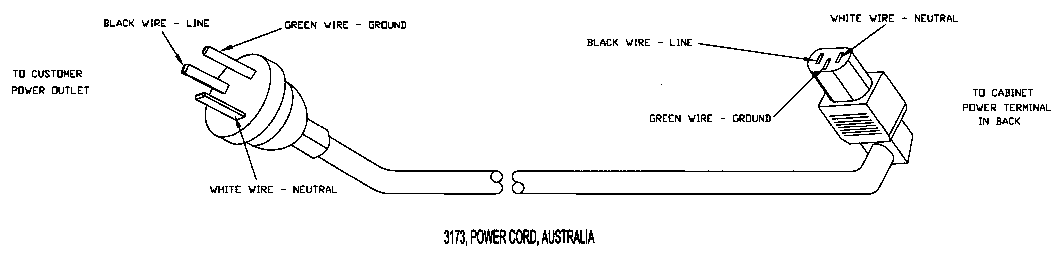
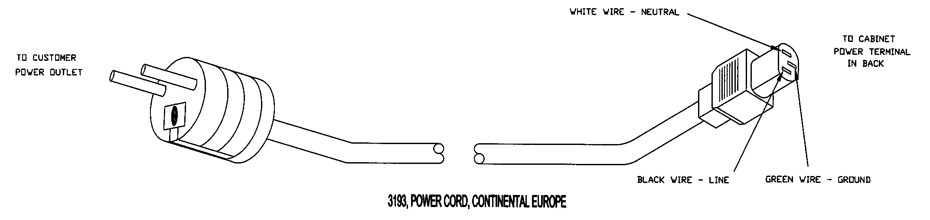
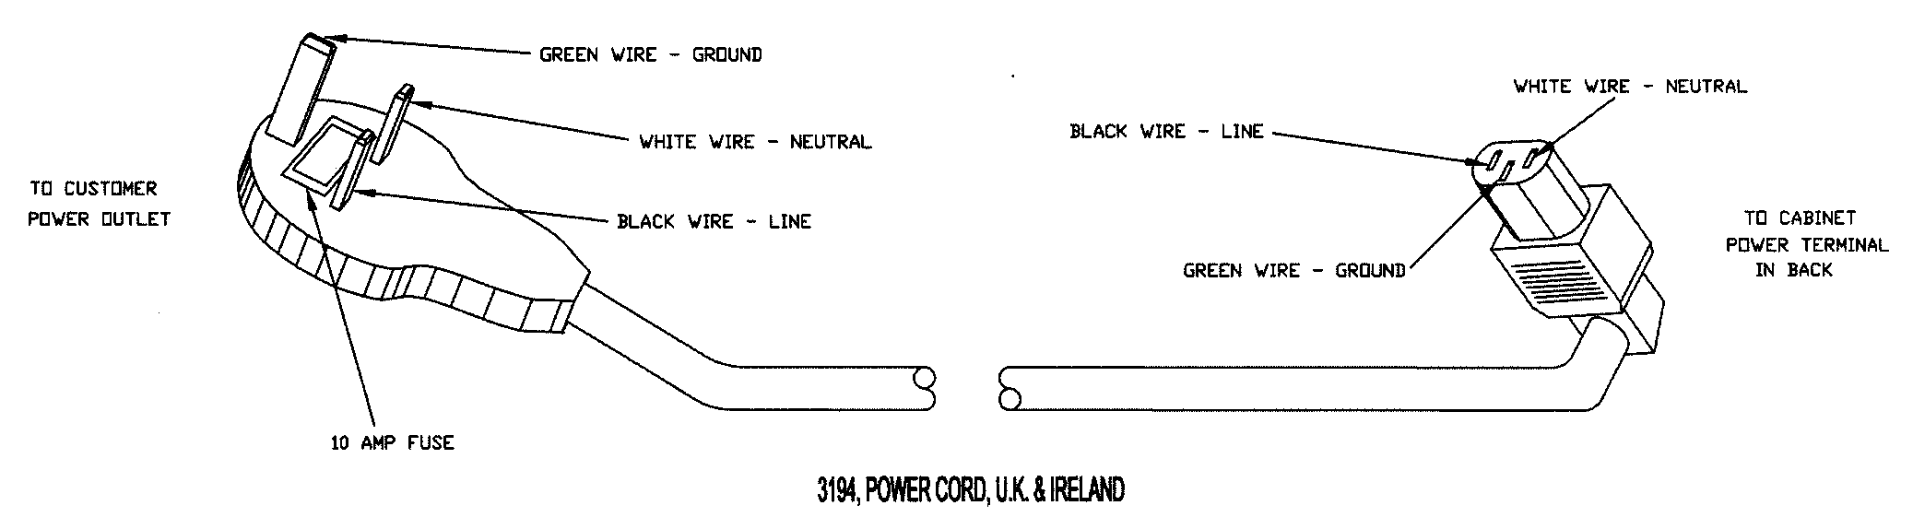
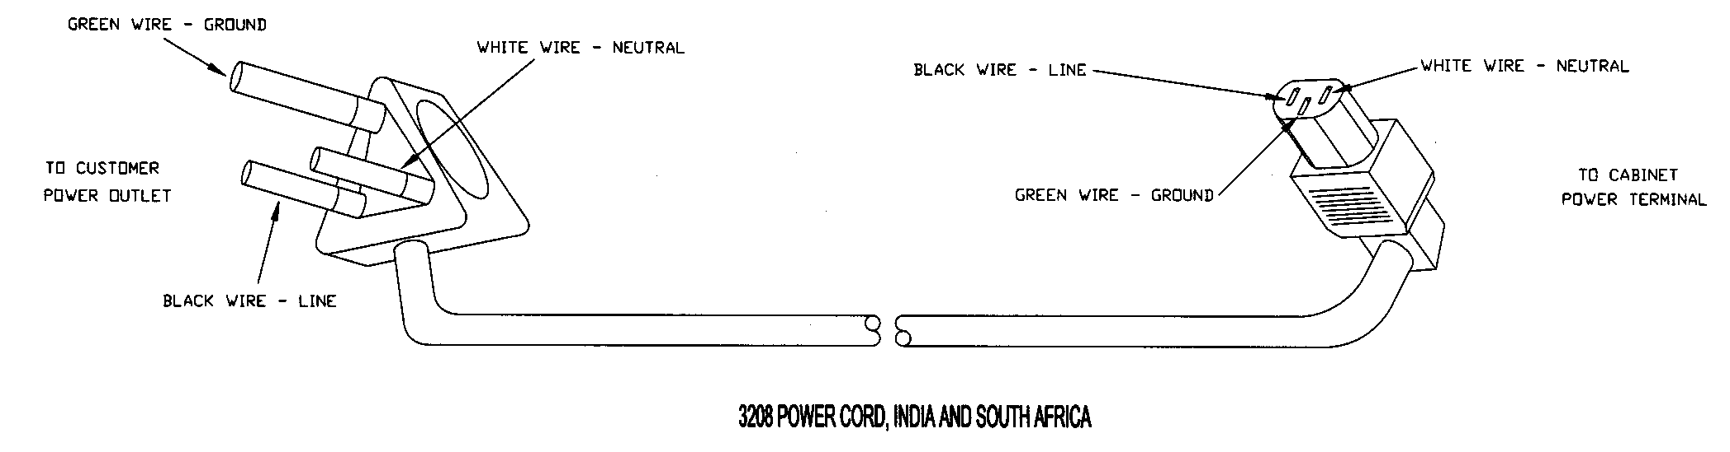

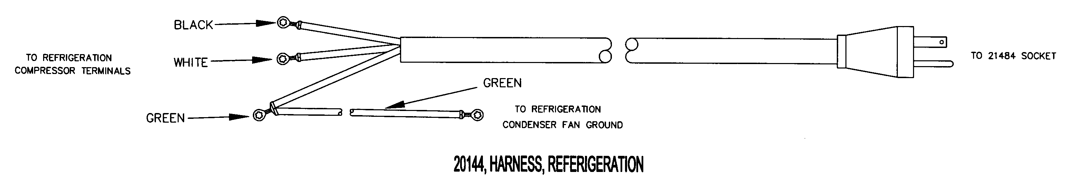
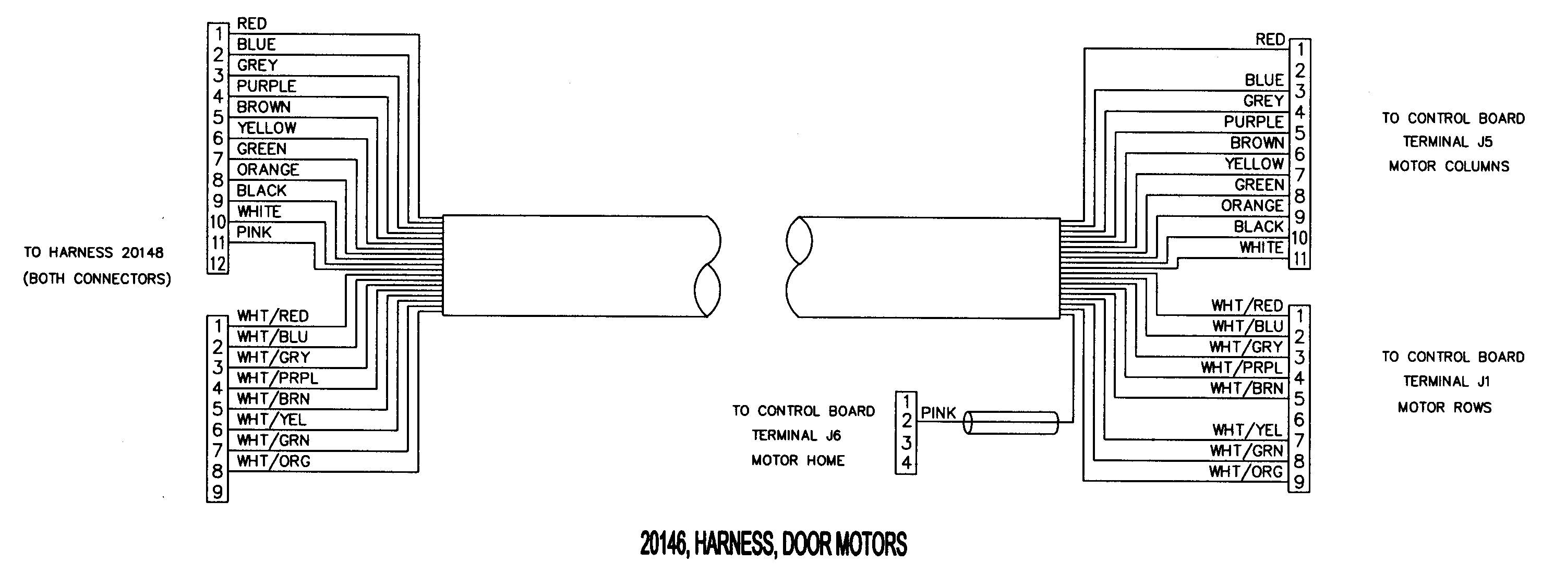

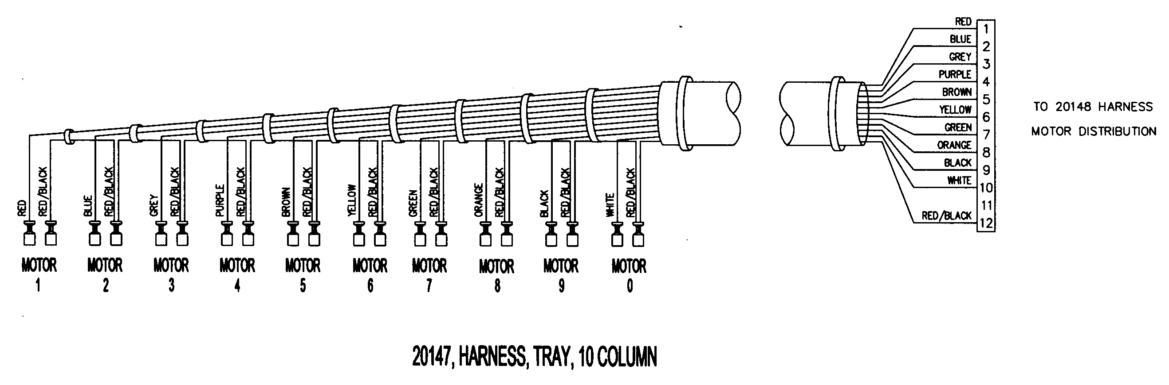

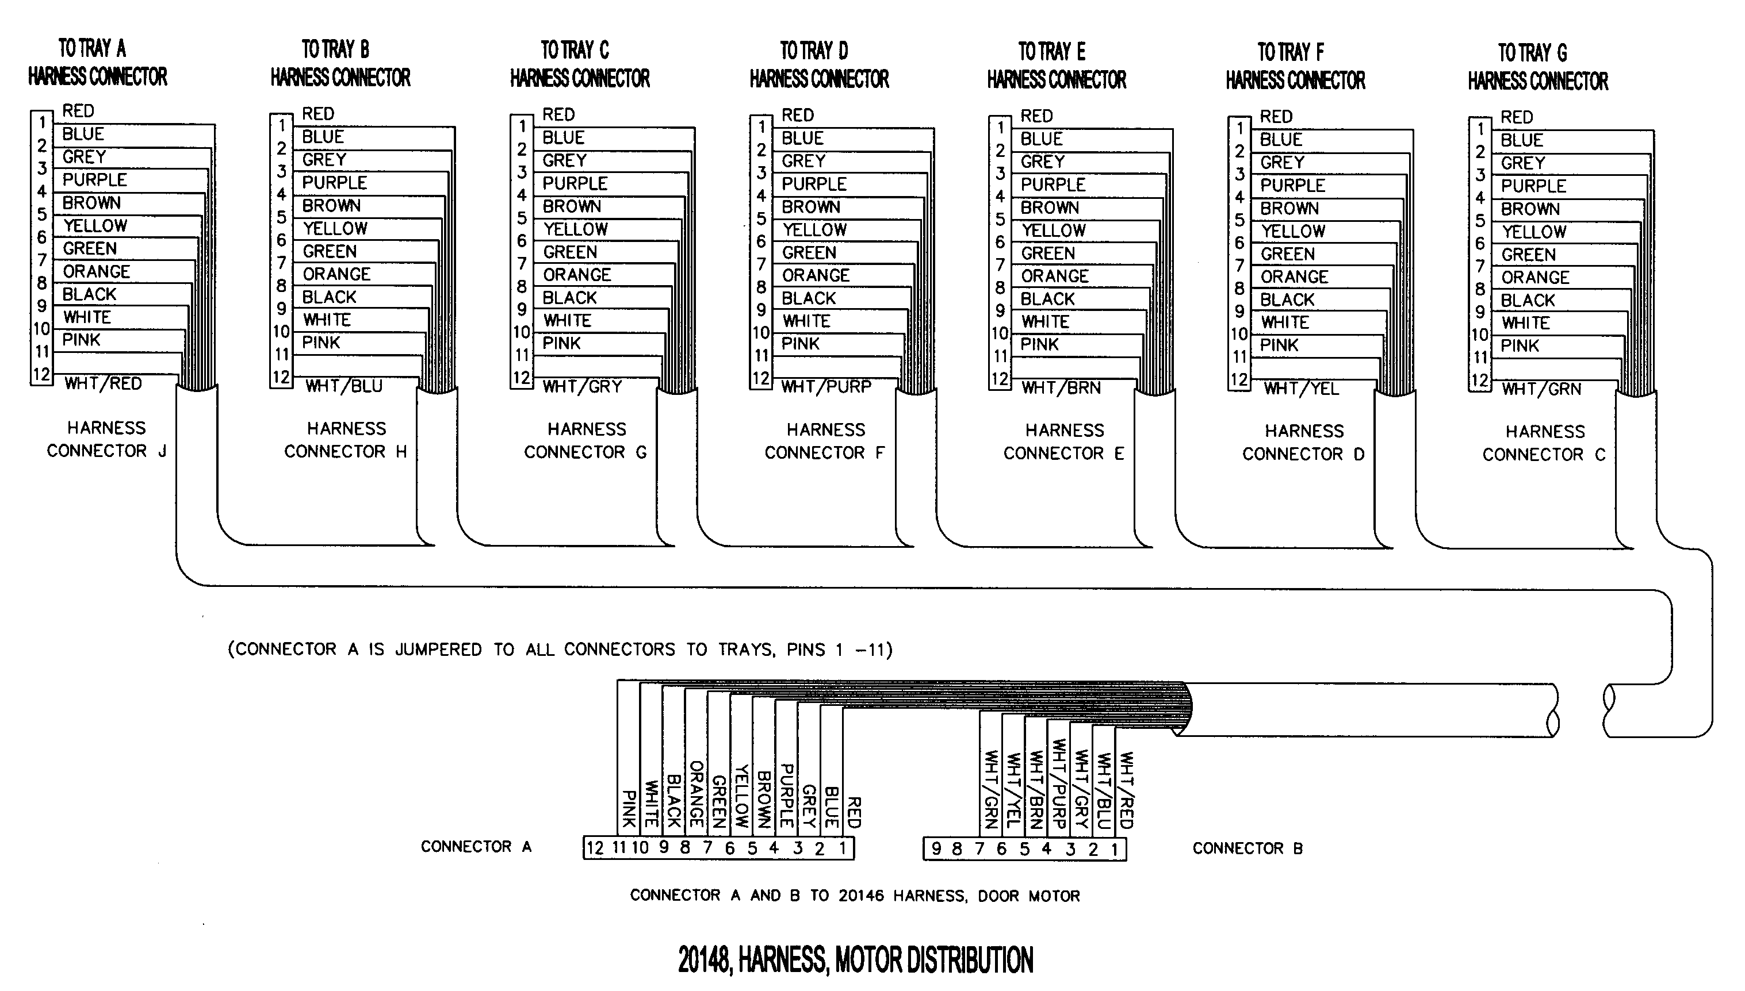

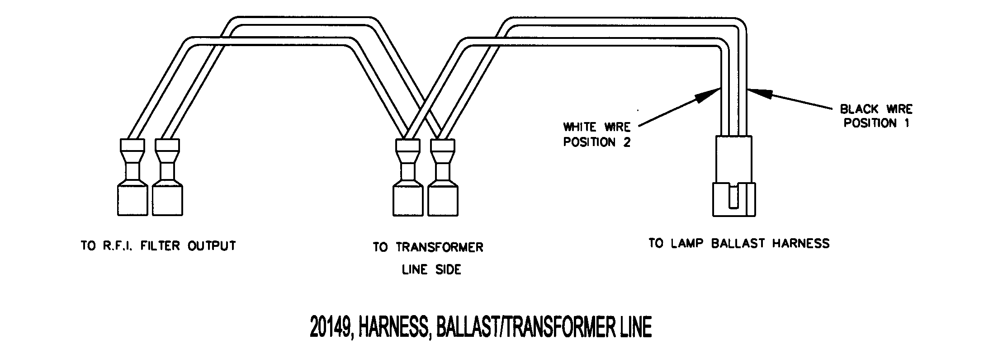

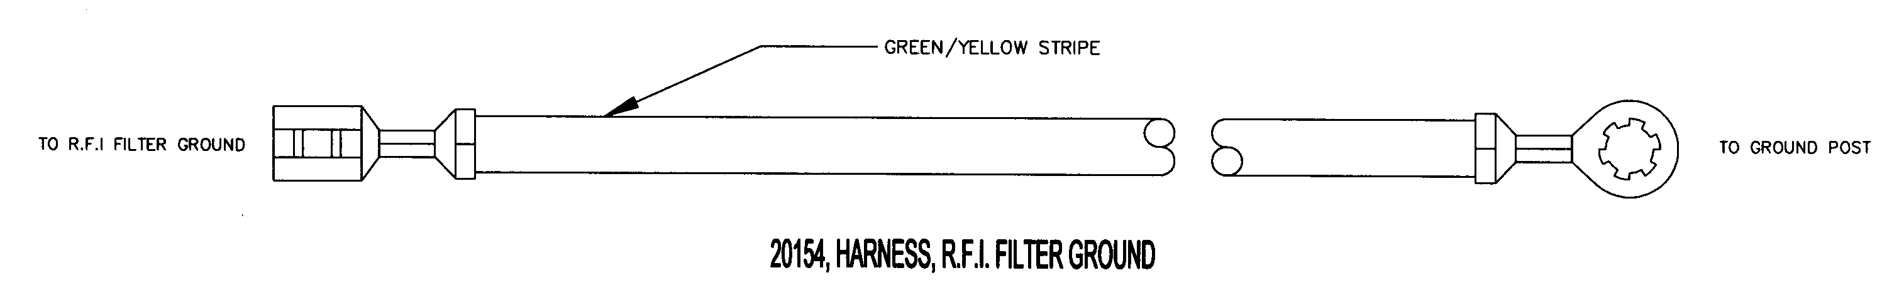

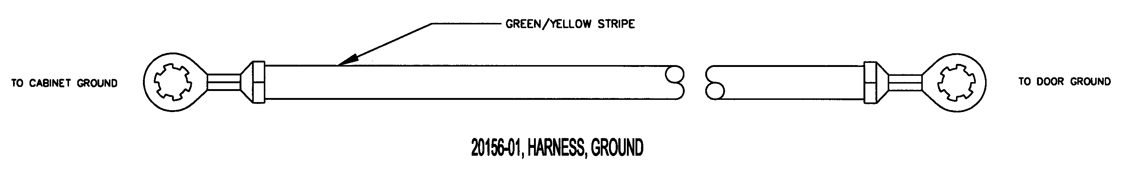

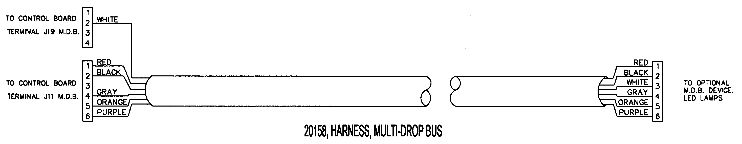

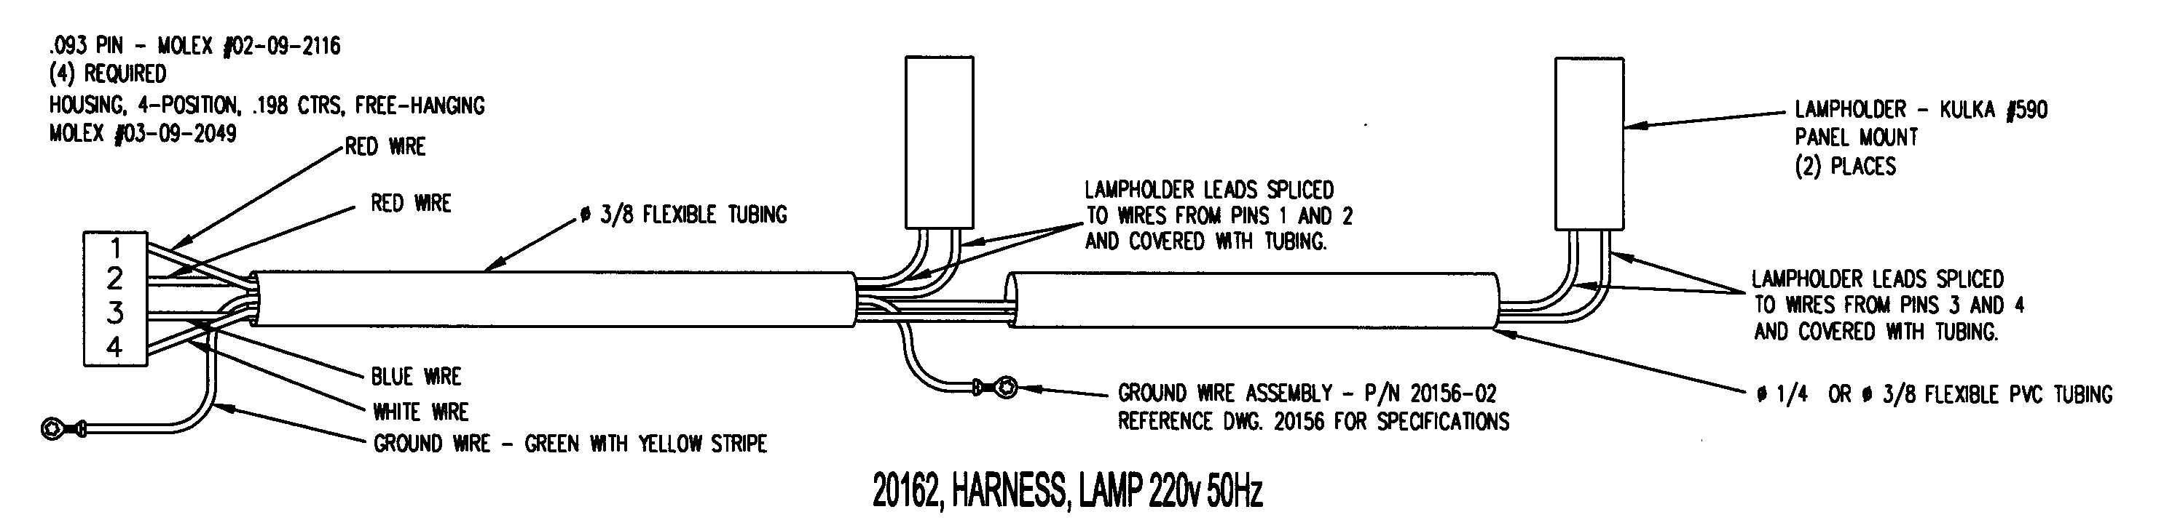

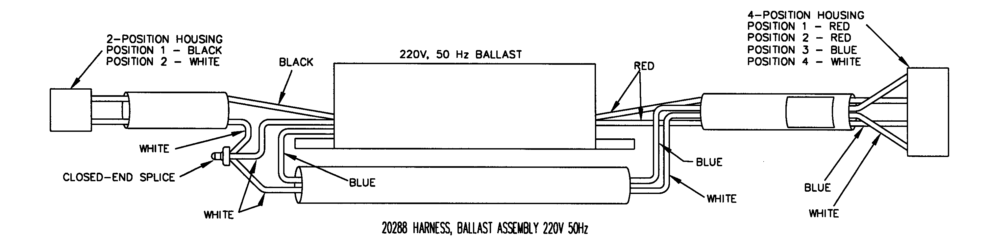

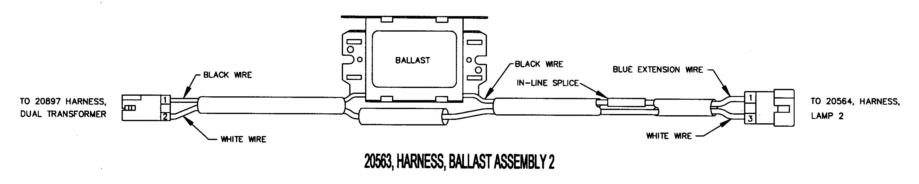

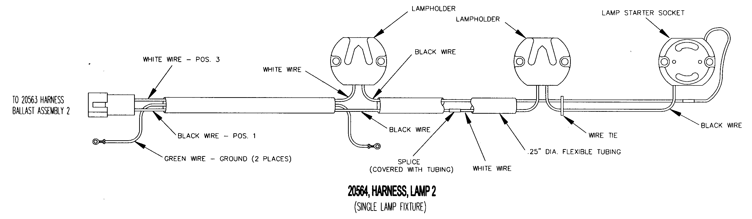
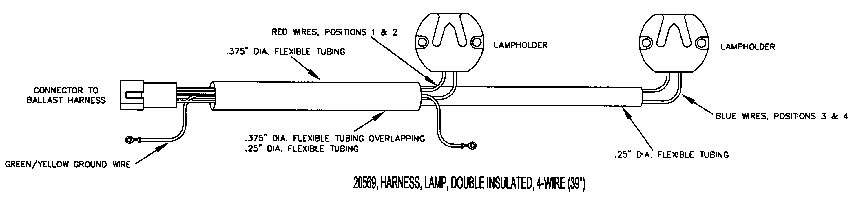
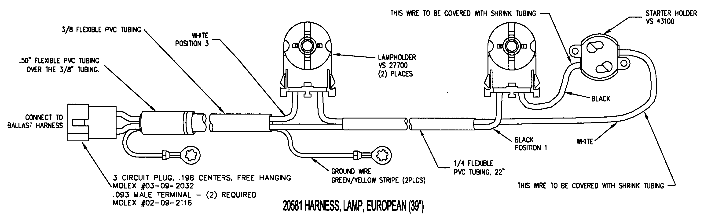

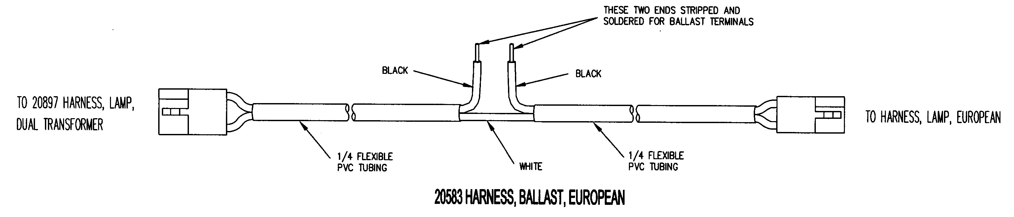

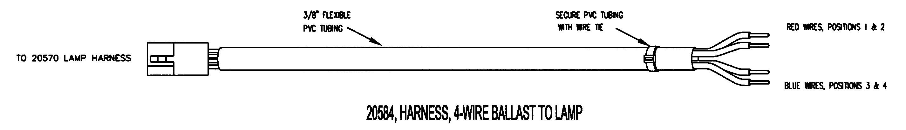


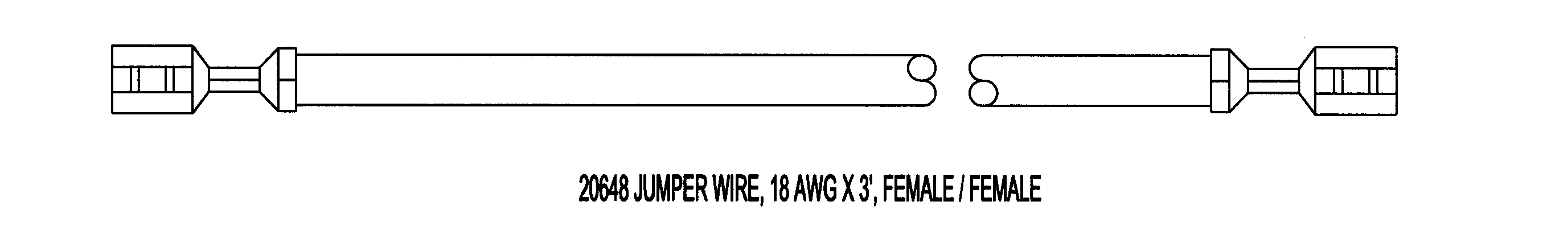
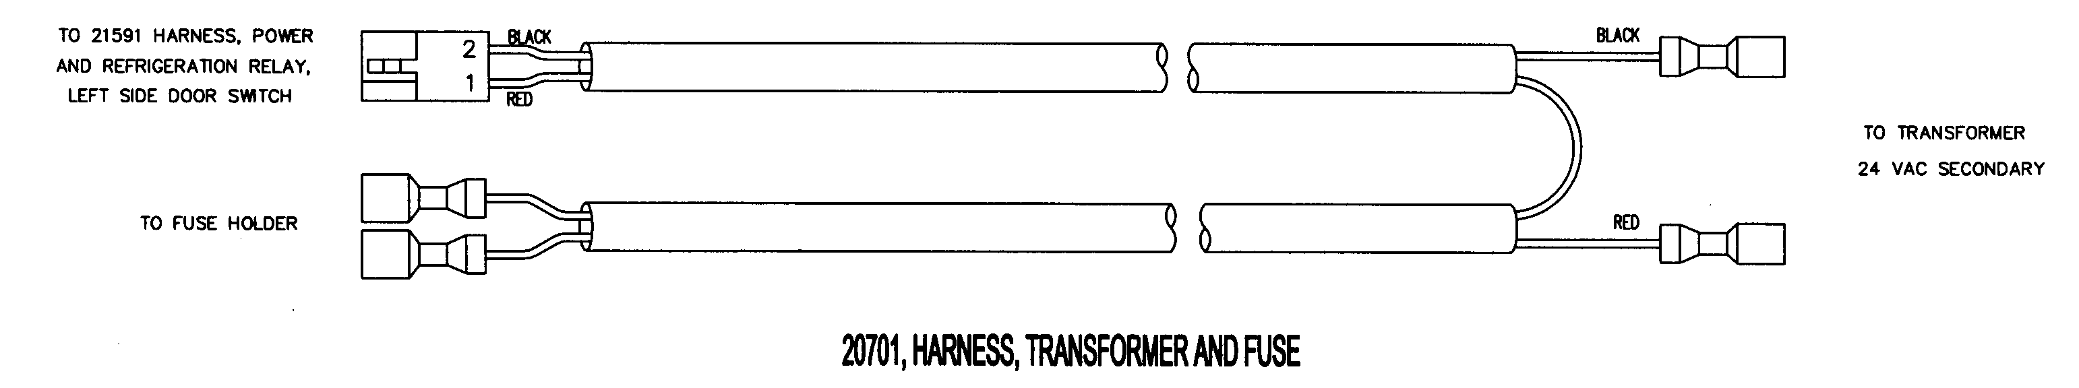

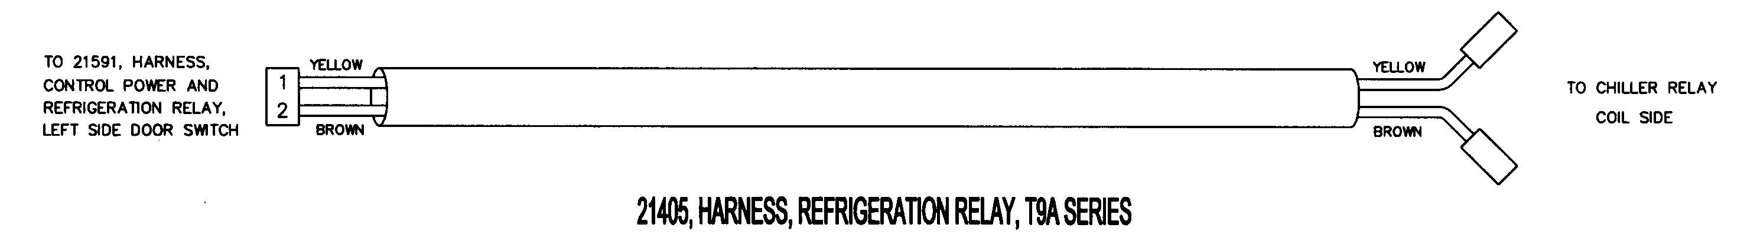

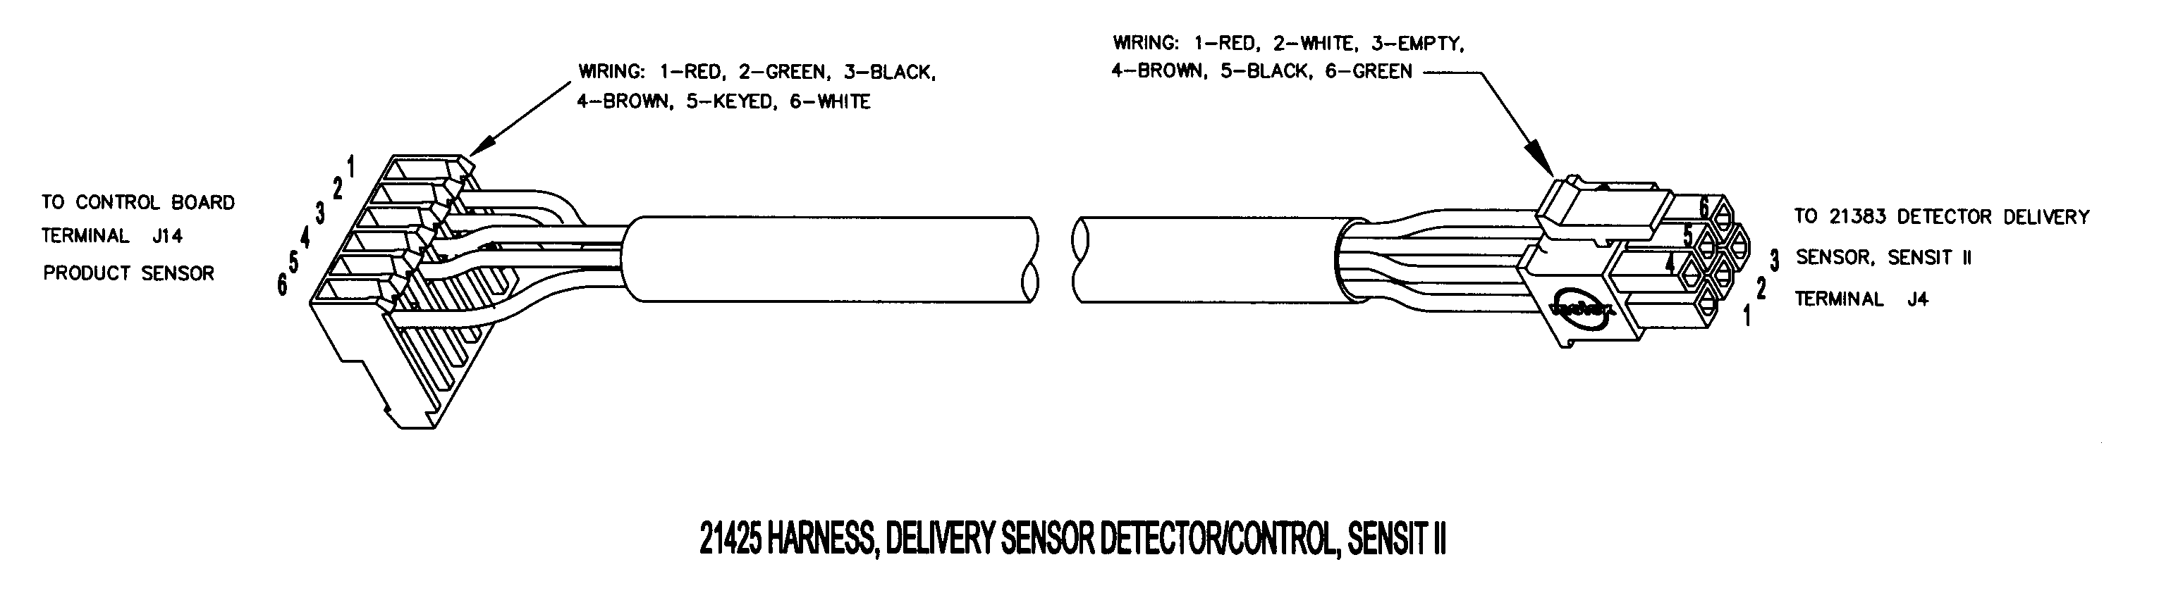

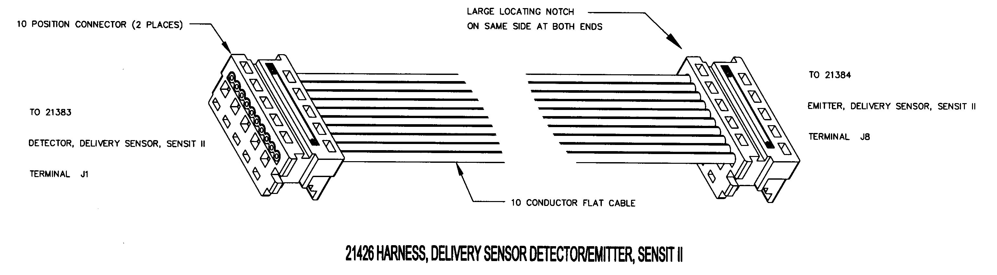

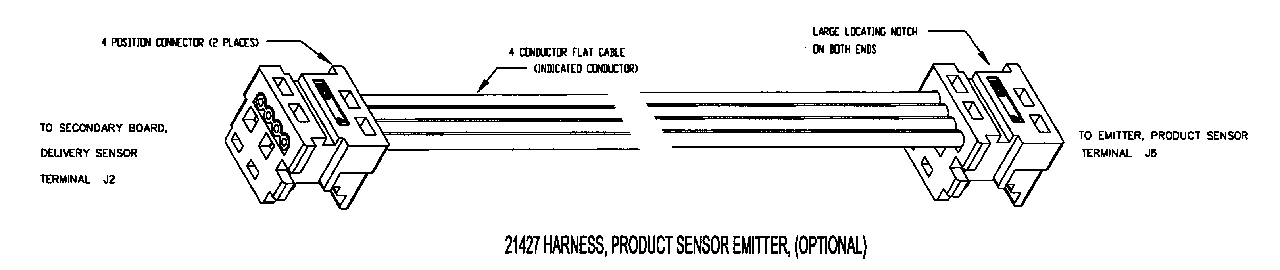

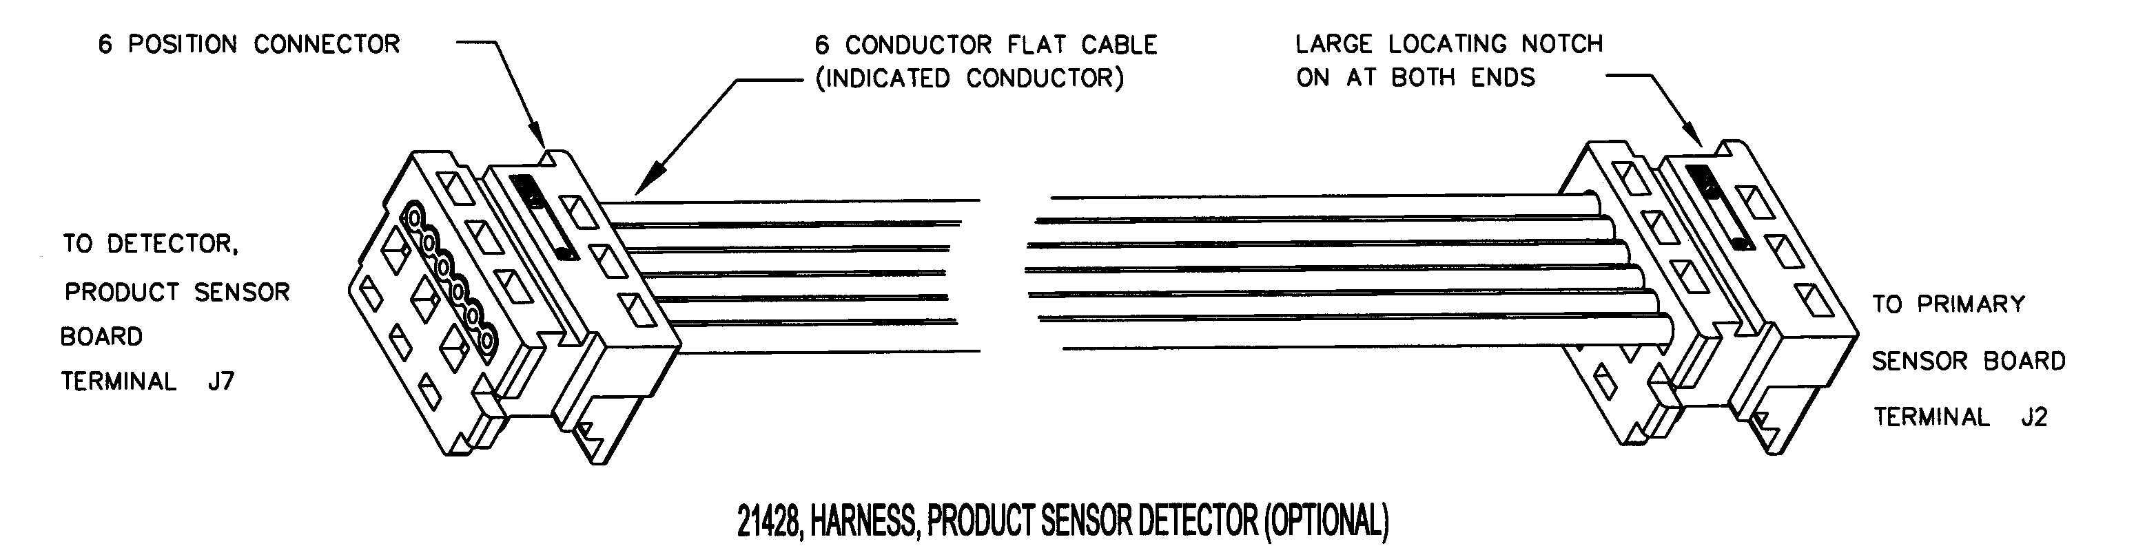

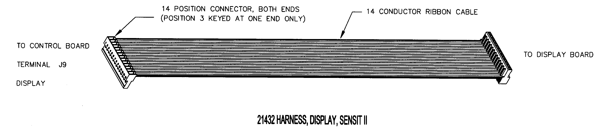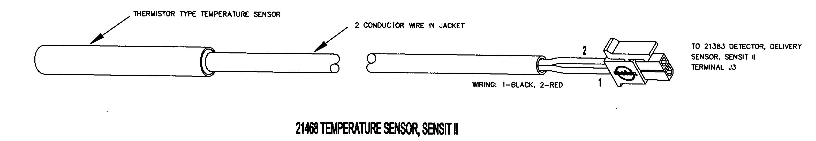

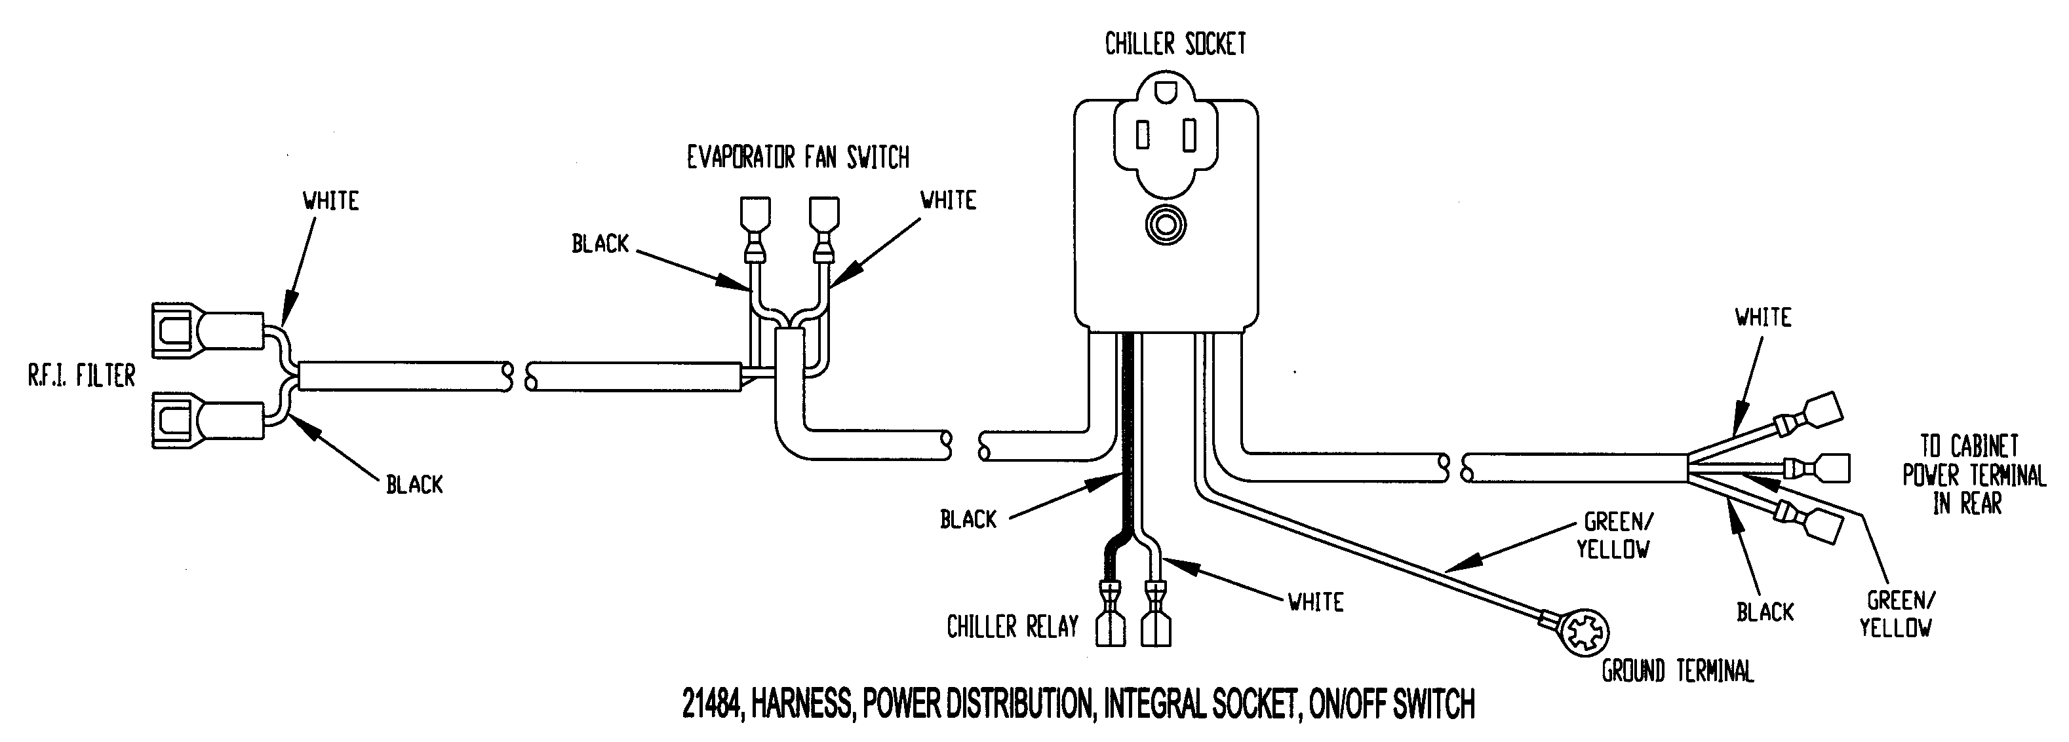

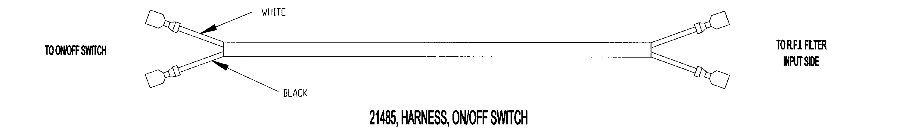

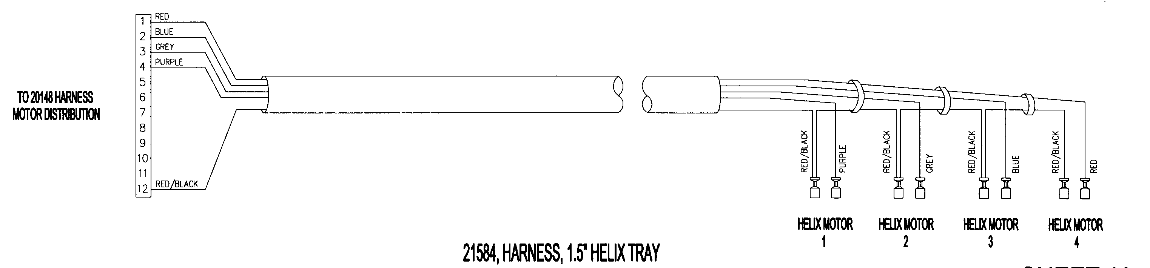

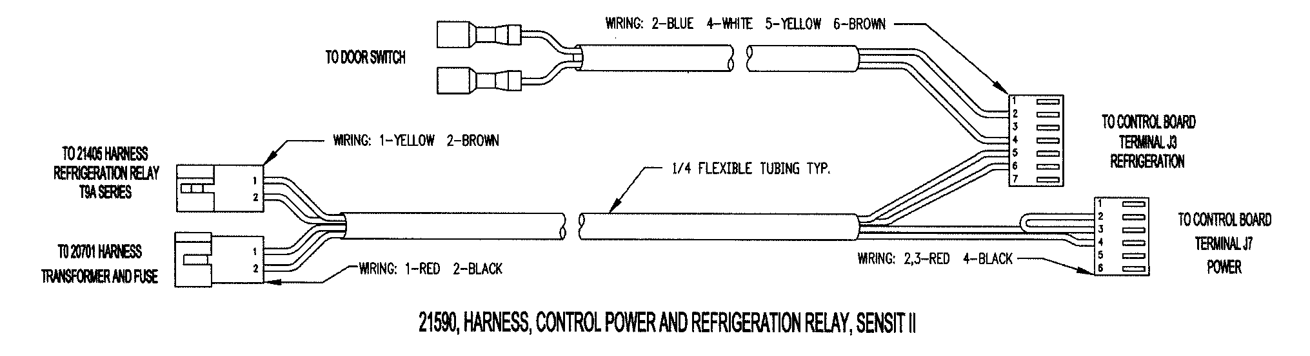

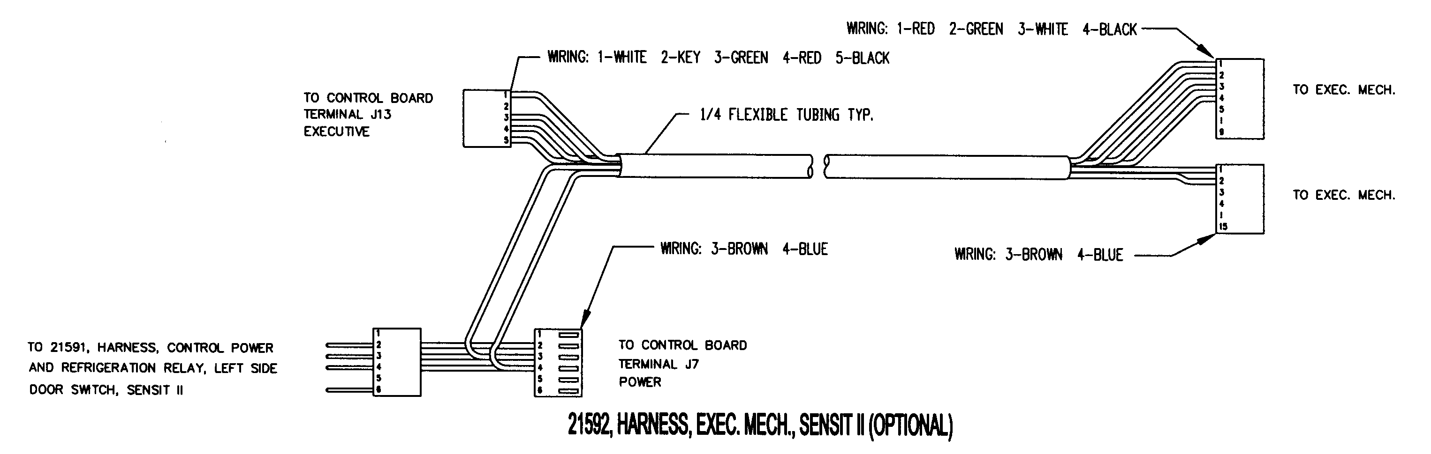

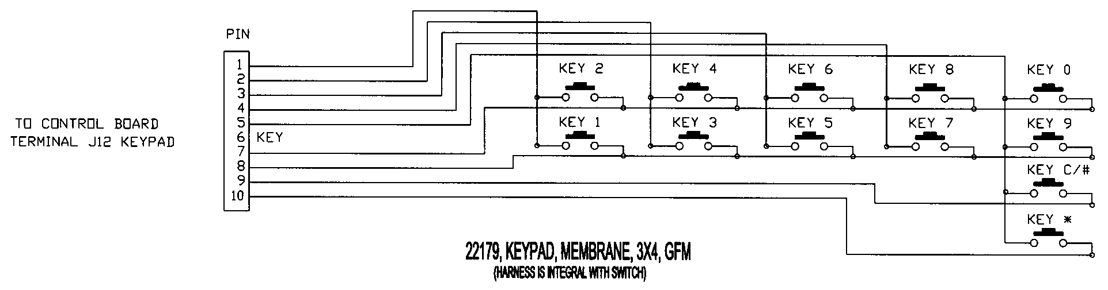

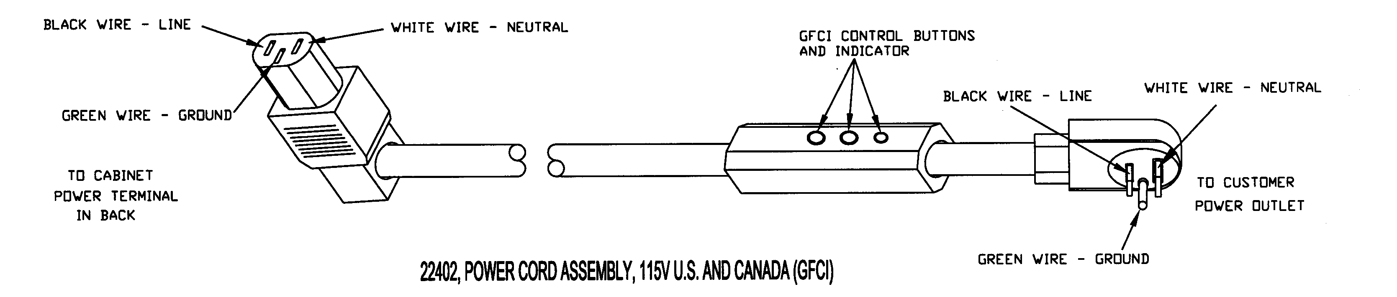



ELECTRICAL HARNESS PARTS LIST
PART NO. | PART DESCRIPTION | QTY | NOTES
3173 | Power Cord, Australia | 1
3193 | Power Cord, Continental Europe | 1
3194 | Power Cord, U.K. and Ireland | 1
3208 | Power Cord, India and South Africa
20142 | Power Cord Assembly, 115V Domestic |  | Use for Mexico
20144 | Harness, Refrigeration | 1 | For Chiller Power
20146 | Harness, Door Motors | 1
20147 | Harness, Tray, 10 Column | 1 | Use For 5 Column Tray
20148 | Harness, Motor Distribution | 1
20149 | Harness, Ballast/Transformer Line | 1
20154 | Harness, R.F.I. Filter Ground | 1
20156-01 | Harness, Ground | 1
20158 | Harness, Multi-Drop Bus | 1 | Use For Both SII and S3
20162 | Harness, Lamp 220V 50Hz | 1 | Use for Israel and South Africa
20288 | Harness, Ballast Assembly, 220V, 50Hz |  | Single Lamp Option, 220V
20563 | Harness, Ballast, Assembly 2 | 1 | Single Lamp Option, 110V
20564 | Harness, Lamp 2 |  | Single Lamp Option, 110V
20569 | Harness, Lamp, Double Insulated 4-Wire (39”) | 1 | Australia 240V Single
20581 | Harness, Lamp European (39”) | 1 | For Single Lamp 220V
20583 | Harness, Ballast, European | 1 | For Single Lamp 220V, (See Ballast, P/N 3158).
20584 | Harness, 4-Wire Ballast to Lamp | 1 | Australia 240V Single
20585 | Harness, Ballast Power | 1 | Australia 240V Single
20648 | Jumper Wire | 2 | Australia 240V Single
20701 | Harness, Transformer and Fuse | 1
21405 | Harness, Refrigeration Relay T9A | 1
21425 | Harness, Delivery Sensor Detector/Control, Sensit II | 1 | Primary to Control Board
21426 | Harness, Delivery Sensor Detector/Emitter, Sensit II | 1 | Secondary to Primary Board
21427 | Harness, Product Sensor Emitter, Sensit II (Optional) | 1 | Secondary to Emitter Board
21428 | Harness, Product Sensor Detector, Sensit II (Optional) | 1 | Primary to Detector Board
24338 | Lighted POS Power Harness | 1
21432 | Harness, Display, Sensit II | 1
21468 | Temperature Sensor, and Harness, Sensit II | 1 | Integral to Sensor, for Chiller
21484 | Harness, Power Distribution, Integral Socket | 1
21485 | Harness, On/Off Switch | 1
21584 | Harness, 1.5” Helix Tray | 1
21590 | Harness, Control Power & Refrigeration Relay, Sensit II | 1
21592 | Harness, Executive Mech Connector, Sensit II | 1
22179 | Keypad Membrane, 3X4, GFM | 1 | Harness is Integral With Keypad
22402 | Power Cord Assembly, 115, US and Canada | 1 | With GFCI, Use in U.S. and Canada
23624 | Harness, Transformer, No Ballast | 1 | Use with LED Lighting
Note: Some assemblies, such as the keypad, are fabricated with the harness as a unit. These are replaceable only as a unit.
Some harness assemblies listed above are for options which may not have been contracted for and installed by AMS.

HELIX ILLUSTRATIONS

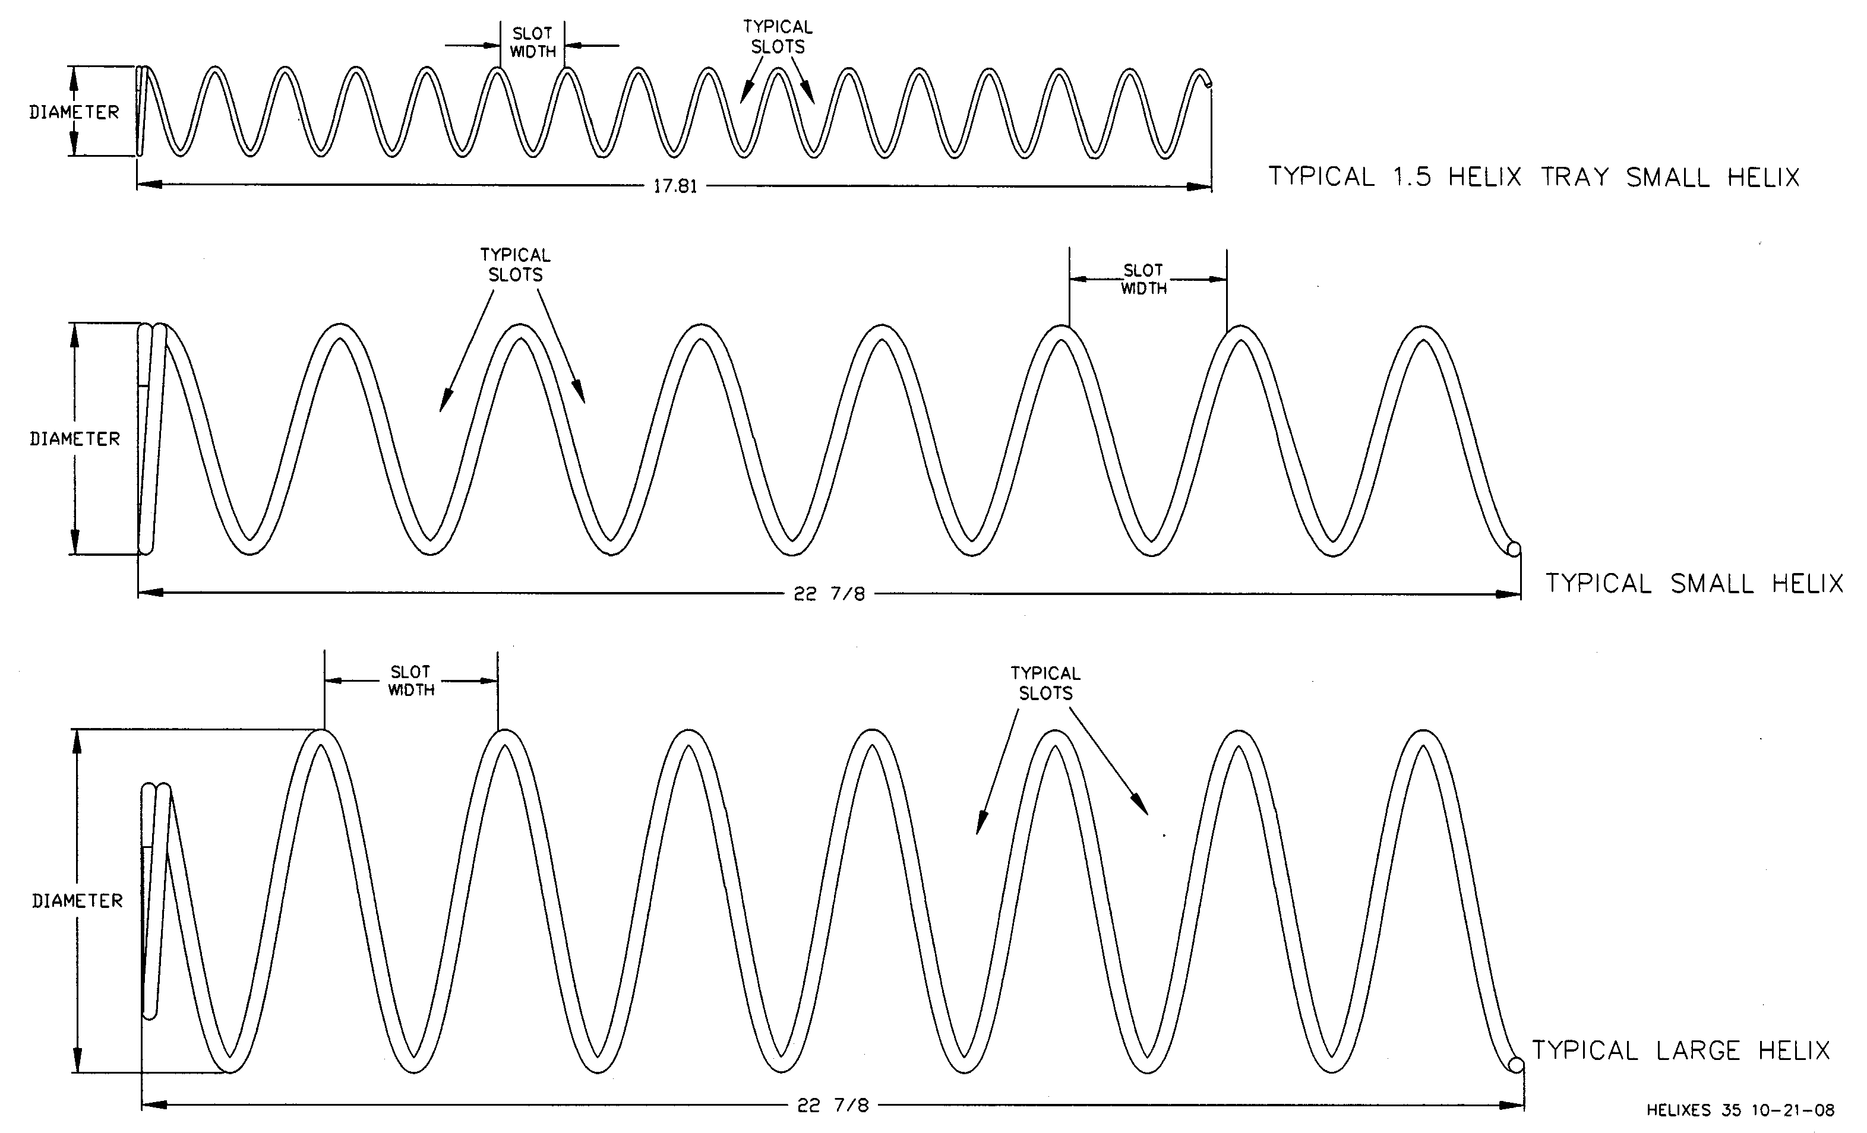

HELIX PARTS LIST
PART  NO. | HELIX DESCRIPTION * | SLOT  (VEND)  WIDTH | NUMBER  OF SLOTS  (PITCH) | HELIX  OUTSIDE  DIAMETER | TURNS | QTY PER COLUMN | NOTE
20119-07 | Helix, Small CW, Black | 2 5/8 | 7 | 2.6 | CW | 1 Set | Use With 20120-07 As A Set
20120-07 | Helix, Small CCW, Black | 2 5/8 | 7 | 2.6 | CCW | 1 Set
20119-10 | Helix, Small CW, Black | 1 7/8 | 10 | 2.6 | CW | 1 Set | Use With 20120-10 As A Set
20120-10 | Helix, Small CCW, Black | 1 7/8 | 10 | 2.6 | CCW | 1 Set
20120-12 | Helix, Small CCW, Black | 1 7/8 | 12 | 2.6 | CCW | 1
20120-15 | Helix, Small CCW, Black | 1 7/8 | 15 | 2.6 | CCW | 1
20120-18 | Helix, Small CCW, Black | 1 7/8 | 18 | 2.6 | CCW | 1
20120-24 | Helix, Small CCW, Black | 1 7/8 | 24 | 2.6 | CCW | 1
21207-15 | Helix, 1.5”, CCW, Black | 1 | 15 | 1.5 | CCW | 1 | Use in 1.5” Helix Tray
21207-25 | Helix, 1.5”, CCW, Black | 9/16 | 25 | 1.5 | CCW | 1 | Use in 1.5” Helix Tray
21336 | Helix, 3”, CCW, Black | 3.5 | 6 | 3 | CCW | 1 | Bottle Tray
21337 | Helix, 3”, CCW, Black | 3.2 | 6 | 3 | CCW | 1 | Bottle Tray
21465-05 | Helix, 3.75” CCW, Black | 3 ¼ | 5 | 3.75 | CCW | 1 | Large Diameter
21465-07 | Helix, 3.75” CCW, Black | 2 5/8 | 7 | 3.75 | CCW | 1 | Large Diameter
21465-09 | Helix, 3.75” CCW, Black | 2 | 9 | 3.75 | CCW | 1 | Large Diameter
21465-10 | Helix, 3.75” CCW, Black | 1 ¾ | 10 | 3.75 | CCW | 1 | Large Diameter
21465-12 | Helix, 3.75” CCW, Black | 1 ½ | 12 | 3.75 | CCW | 1 | Large Diameter
21465-15 | Helix, 3.75” CCW, Black | 1 ¼ | 15 | 3.75 | CCW | 1 | Large Diameter
Contact your distributor for special helix diameters and pitch.
Contact AMS for your application.

1.5” HELIX TRAY ILLUSTRATION

1.5” HELIX TRAY PARTS LIST
ITEM NO | PART NO. | PART NAME | QTY | NOTES
1 | 3000 | Screw, TEK 8-18 | 18
2 | 3009-02 | Rivet, Pop, Steel, 1/8 | 34
3 | 3246 | Latch, Nylon, Gum and Mint | 2
4 | 3247 | Strike, Nylon, Gum and Mint | 2
5 | 23007 | Motor, Single Helix | 4
6 | 20236 | Extrusion, Gum and Mint Rail | 2
7 | 20237 | Extrusion Mount, Upper (Gum and Mint)(Right Side) | 1
8 | 20237-01 | Extrusion Mount, Upper (Gum and Mint)(Left Side) | 1
9 | 20238 | Extrusion Mount, Lower (Gum and Mint)(Right Side) | 1
10 | 20238-01 | Extrusion Mount, Lower (Gum and Mint)(Left Side) | 1
11 | 20465-04 | Extrusion, Price Marker, Reduced Height | 1
12 | 21046 | Rail, Gum and Mint, Reduced Depth (35”)(Right Side) | 1 | Rails To Fit Tray To 35” Cabinet
12 | 20973 | Rail, Gum and Mint, Reduced Depth (39”)(Right Side) | 1 | Rails To Fit Tray To 39” Cabinet
13 | 21046-01 | Rail, Gum and Mint, Reduced Depth (35”)(Left Side) | 1 | Rails To Fit Tray To 35” Cabinet
13 | 20973-01 | Rail, Gum and Mint, Reduced Depth (39”)(Left Side) | 1 | Rails To Fit Tray To 39” Cabinet
14 | 21196 | Doubler, Tray 1.5” Helix Tray | 1
15 | 21197 | Tray Body, 1.5” Helix Tray | 1 | Parts Are Factory Assembled As A Unit
16 | 21199 | Tray Back, 1.5” Helix Tray | 1 | Parts Are Factory Assembled As A Unit
17 | 21200 | Tray Inner Side, 1.5” Helix Tray | 2 | Parts Are Factory Assembled As A Unit
18 | 21201 | Tray Inner Section, 1.5” Helix Tray | 2 | Parts Are Factory Assembled As A Unit
19 | 21202 | Tray Inner Mid Section, 1.5” Helix Tray | 1 | Parts Are Factory Assembled As A Unit
20 | 21203 | Divider, Tray, 1.5” Helix Tray, RH | 4
21 | 21203-01 | Divider, Tray, 1.5” Helix Tray, LH | 4
22 | 21204 | Tray Slide Channel,1.5” Helix Tray, RH | 1
23 | 21204-01 | Tray Slide Channel,1.5” Helix Tray, LH | 1
24 | 21206 | Helix Adapter, 1.5” Helix Tray | 4
25 | 21207-15 | Helix, 1.5” Tray, Counterclockwise, Black | 2 | Tray is Equipped With Two of Each
26 | 21207-25 | Helix, 1.5” Tray, Counterclockwise, Black | 2 | Tray is Equipped With Two of Each
27 | 21523 | Bracket, Stop, 1.5” Helix Tray | 2
28 | 21584 | Harness, 1.5” Helix Tray | 1
29 | 22387 | Deflector, 1.5” Helix Tray, RH (39”) |  | Use When 1.5” Tray Is Installed
30 | 22387-01 | Deflector, 1.5” Helix Tray, LH, (39”) |  | Use When 1.5” Tray Is Installed
***Tray also comes in scrolling price option. Contact your distributor for details.

UNIVERSAL (SNACK/CANDY/FOOD) TRAY ILLUSTRATION

MODEL 35 & 39 (SNACK/CANDY/FOOD) STANDARD TRAY PARTS LIST
ITEM NO | PART NO. | PART DESCRIPTION | NOTE
1 | 20073 | TRAY STOP
2 | 20073-01 | TRAY STOP, LH
3 | ----- | HELIX | 1 PER COLUMN. SEE HELIX SECTION
4 | 20147 | HARNESS, TRAY 10 COLUMN
5 | 20220 | EXTRUSION, CANDY PUSHER | OPTIONAL, 2 PER 20221 & DIVIDER WITH CUTOUTS
6 | 20221 | BAR, CANDY PUSHER | OPTIONAL, 1 PER DIVIDER WITH CUTOUTS
7 | 20450 | KIT, HELIX SPLITTER | OPTIONAL, 1 PER SELECTION
8 | 20465-02 | EXTRUSION, PRICE MARKER, REDUCED HEIGHT (35”)
8 | 20465-01 | EXTRUSION, PRICE MARKER, REDUCED HEIGHT (39”)
9 | 20535 | KIT, CUP RAIL, SMALL HELIX | OPTIONAL, 1 PER SELECTION
9 | 20536 | KIT, CUP RAIL, 4” HELIX | OPTIONAL, 1 PER SELECTION
10 | 20643 | TRAY DOUBLER, VER. 2 (35”)
10 | 20544 | TRAY DOUBLER, VER. 2 (39”)
11 | 20545 | TRAY CORNER, VER. 2 (RH)
12 | 20545-01 | TRAY CORNER, VER. 2 (LH)
13 | 20614 | LABEL SHEET, REDUCED HEIGHT, PRICE
14 | 20796-01 | EDGE TRIM, TRAY CORNER | RIGHT HAND CORNER ONLY
15 | 21045 | TRAY BODY, REDUCED DEPTH (35”)
15 | 20955 | TRAY BODY, REDUCED DEPTH (39”)
16 | 20966 | HELIX ADAPTOR, WITHOUT HUB
17 | 21138 | ASSEMBLY, TRAY DIVIDER | INCLUDES DIVIDER WITH 20133 SPRING, SELECT TYPE, NUMBERS TO FORM COLUMNS
17 | 21139 | ASSEMBLY, TRAY DIVIDER, HIGH
17 | 23664 | ASSEMBLY, TRAY DIVIDER, EXTRA HIGH
18 | 22192 | HELIX ALIGNMENT DEVICE, PVC
19 | 22908 | LABEL SHEET, REDUCED HEIGHT, PRICE W/$
20 | 22909 | LABEL SHEET, REDUCED HEIGHT, LOCATION, WHITE
21 | 23007 | MOTOR, WITH HOME CIRCUIT, CCW | OPTIONAL
21 | 23007-01 | MOTOR, WITH HOME CIRCUIT, CW | OPTIONAL
22 | 24046 | KIT, MINI-DISPENSER | OPTIONAL, 1 PER SELECTION
23 | 22250 | ASSEMBLY, TRAY RAIL, SNACK (RH)
24 | 22251 | ASSEMBLY, TRAY RAIL, SNACK (LH)
25 | 3000 | SCREW, SHEET METAL TEK – 8-18
26 | 3001-03 | SCREW, SHEET METAL, TYPE B, #8-18 | SAFETY SCREWS FOR RAILS
27 | 3009-02 | RIVET, STEEL, BLACK 1/8 DIA X 1/8 GRIP
28 | 3009-04 | RIVET, STEEL, BLACK 1/8 DIA X ¼ GRIP
29 | 3019 | CANOE CLIP | 2 PER HELIX ALIGNMENT DEVICE
30 | 3020 | WIRE TIE, STAND OFF
31 | 3042-01 | WIRE TIE, PANEL MOUNT
32 | 3111 | HELIX EJECTOR
33 | 3295-03 | RIVET, STEEL, 1/8”, PLATED
***Tray also comes in scrolling price option. Contact your distributor for details.

THIS PAGE INTENTIONALLY LEFT BLANK
35” & 39” HIGH CAPACITY HEAVY PRODUCT TRAY ILLUSTRATION

35 & 39 HIGH CAPACITY HEAVY PRODUCT TRAY PARTS LIST
ITEM NO | PART NO. | PART DESCRIPTION | NOTE
1 | 20073 | TRAY STOP
2 | 20073-01 | TRAY STOP, LH
*3 | 20465-02 | EXTRUSION, PRICE MARKER, REDUCED HEIGHT (35”)
*3 | 20465-01 | EXTRUSION, PRICE MARKER, REDUCED HEIGHT (39”)
4 | 20545 | TRAY CORNER, VER. 2 (RH)
5 | 20545-01 | TRAY CORNER, VER. 2 (LH)
6 | 20643 | TRAY DOUBLER, VER. 2 (35”)
6 | 20544 | TRAY DOUBLER, VER. 2 (39”)
7 | 20796-01 | EDGE TRIM, TRAY CORNER | RIGHT HAND CORNER ONLY
8 | 21958 | TRAY REINFORCEMENT (35”)
8 | 22831 | TRAY REINFORCEMENT (39”)
9 | 24094 | TRAY BODY, HCHP, REDUCED DEPTH (35”)
9 | 24055 | TRAY BODY, HCHP, REDUCED DEPTH (39”)
10 | 3001-03 | SCREW, SHEET METAL, TYPE B, #8-18
11 | 3009-02 | RIVET, STEEL, BLACK, 1/8 DIA X 1/8 GRIP
12 | 3019 | CANOE CLIP
13 | 3042-01 | WIRE TIE, PANEL MOUNT
14 | 3295-03 | RIVET, STEEL, 1/8”, PLATED
15 | 20966 | HELIX ADAPTOR, WITHOUT HUB
16 | 3111 | HELIX EJECTOR
17 | 23333 | TRAY DIVIDER, 3-3/8” | SELECT TYPE, NUMBERS TO FORM COLUMNS
17 | 23334 | TRAY DIVIDER, 4-7/8” | SELECT TYPE, NUMBERS TO FORM COLUMNS
17 | 23335 | TRAY DIVIDER, 8” | SELECT TYPE, NUMBERS TO FORM COLUMNS
18 | -------- | HELIX | 1 PER COLUMN – SEE HELIX SECTION
19 | 20449 | ASSEMBLY, CANDY PUSHER | OPTIONAL – CONTACT YOU DISTIBUTOR
20 | 23622 | ASSEMBLY, HELIX ALIGNMENT DEVICE | OPTIONAL – CONTACT YOU DISTIBUTOR
21 | 23007 | MOTOR, WITH HOME CIRCUIT, CCW | OPTIONAL – CONTACT YOU DISTIBUTOR

35 & 39 HCHP STANDARD TRAY PARTS LIST
ITEM NO | PART NO. | PART DESCRIPTION | NOTE
22 | 3020 | WIRE TIE, STANDOFF | OPTIONAL – CONTACT YOU DISTIBUTOR
23 | 20147 | HARNESS, TRAY, 10 COLUMN
NOT SHOWN | 22834 | ASSEMBLY, HEAVY PRODUCT RAIL, SERVICE, RH | SUPPLIED
NOT SHOWN | 22835 | ASSEMBLY, HEAVY PRODUCT RAIL, SERVICE, LH | SUPPLIED

*Tray also comes in scrolling price option. Contact your distributor for details.

THIS PAGE INTENTIONALLY LEFT BLANK

35” & 39” HORIZONTAL CAN TRAY ILLUSTRATION

* 35 & 39 HORIZONTAL CAN TRAY PARTS LIST
ITEM NO | PART NO. | PART DESCRIPTION | NOTE
1 | 20120-07 | HELIX, SMALL, CCW, 7-PITCH | 1 PER COLUMN. CONTACT AMS FOR YOUR APPLICATION
1 | 20120-08 | HELIX, SMALL CCW, 8-PITCH | 1 PER COLUMN. CONTACT AMS FOR YOUR APPLICATION
2 | 20147 | HARNESS, TRAY, 10 COLUMN
*3 | 20465-08 | EXTRUSION, PRICE MARKER, 21.2” (35”)
*3 | 20465-07 | EXTRUSION, PRICE MARKER, 26.5” (39”)
4 | 20796-01 | EDGE TRIM, TRAY CORNER | RIGHT HAND CORNER ONLY
5 | 20966 | HELIX ADAPTOR, WITHOUT HUB
6 | 23007 | MOTOR, WITH HOME CIRCUIT, CCW
7 | 24976 | TRAY BODY, HORIZONTAL CAN, 4 SELECT (35”)
7 | 24107 | TRAY BODY, HORIZONTAL CAN, 5 SELECT (39”)
8 | 24110 | SUPPORT, CAN/HELIX, HORIZONTAL CAN TRAY
9 | 24979 | RESTRICTOR, FRONT, HORIZONTAL CAN TRAY, 4 SELECT (35”)
9 | 24112 | RESTRICTOR, FRONT, HORIZONTAL CAN TRAY, 5 SELECT (39”)
10 | 24983 | RESTRICTOR, BACK, HORIZONTAL CAN TRAY, 4 SELECT (35”)
10 | 24113 | RESTRICTOR, BACK, HORIZONTAL CAN TRAY, 5 SELECT (39”)
11 | 24114 | DIVIDER, HORIZONTAL CAN TRAY | CONTACT AMS FOR YOUR APPLICATION
12 | 24978 | REINFORCEMENT, HORIZONTAL CAN TRAY, 35”
12 | 24120 | REINFORCEMENT, HORIZONTAL CAN TRAY, 39”
13 | 24121 | CORNER, LEFT, S/P, HORIZONTAL CAN TRAY
14 | 24122 | CORNER, RICHT, S/P, HORIZONTAL CAN TRAY
15 | 24977 | PANEL, BACK, HORIZONTAL CAN TRAY, 4 SELECT 35”
15 | 24149 | PANEL, BACK, HORIZONTAL CAN TRAY, 5 SELECT 39”
16 | 24171 | SPACER, RAIL SLIDE, HORIZONTAL CAN TRAY
17 | 24191 | RAIL, SLIDE MOUNTING, RH, HORIZONTAL CAN TRAY

* 35 & 39 HORIZONTAL CAN TRAY PARTS LIST
ITEM NO | PART NO. | PART DESCRIPTION | NOTE
18 | 24191-01 | RAIL, SLIDE MOUNTING, LH, HORIZONTAL CAN TRAY
19 | 24984 | DOUBLER, TRAY, HORIZONTAL CAN, 35”
19 | 24224 | DOUBLER, TRAY, HORIZONTAL CAN, 39”
20 | 3000 | SCREW, SHEET METAL, TEK – 8-18
21 | 3001-03 | SCREW, STEEL METAL, TYPE B, #8-18
22 | 3009-02 | RIVET, STEEL, BLACK, 1/8 DIA X 1/8 GRIP
23 | 3020 | WIRE TIE, STANDOFF
24 | 3023-11 | WASHER, FLAT, NYLON
25 | 3042-01 | WIRE TIE, PANEL MOUNT
26 | 3286-03 | SNAP RIVET
27 | 3709-02 | RIVET, STEEL, 3/16 DIA., .125 TO .25 GRIP L

*Tray also comes in scrolling price option. Contact your distributor for details.

