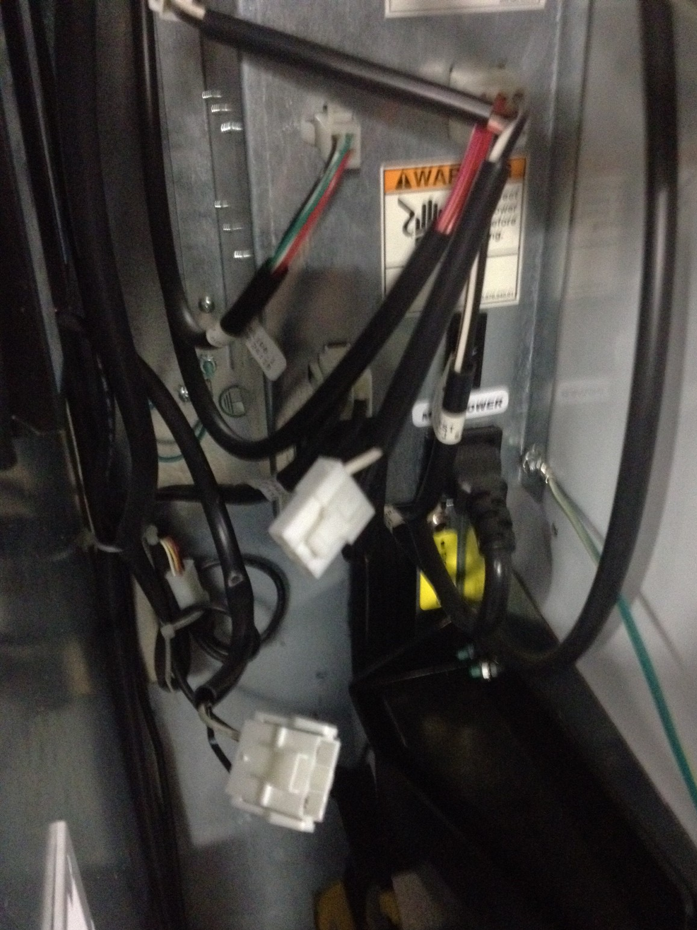
1. There is a 2 pin plug, and a 3 pin plug coming out of the main power box that go to the 2 ballast's.

2 Unplug the 3 pin plug and leave unplugged.

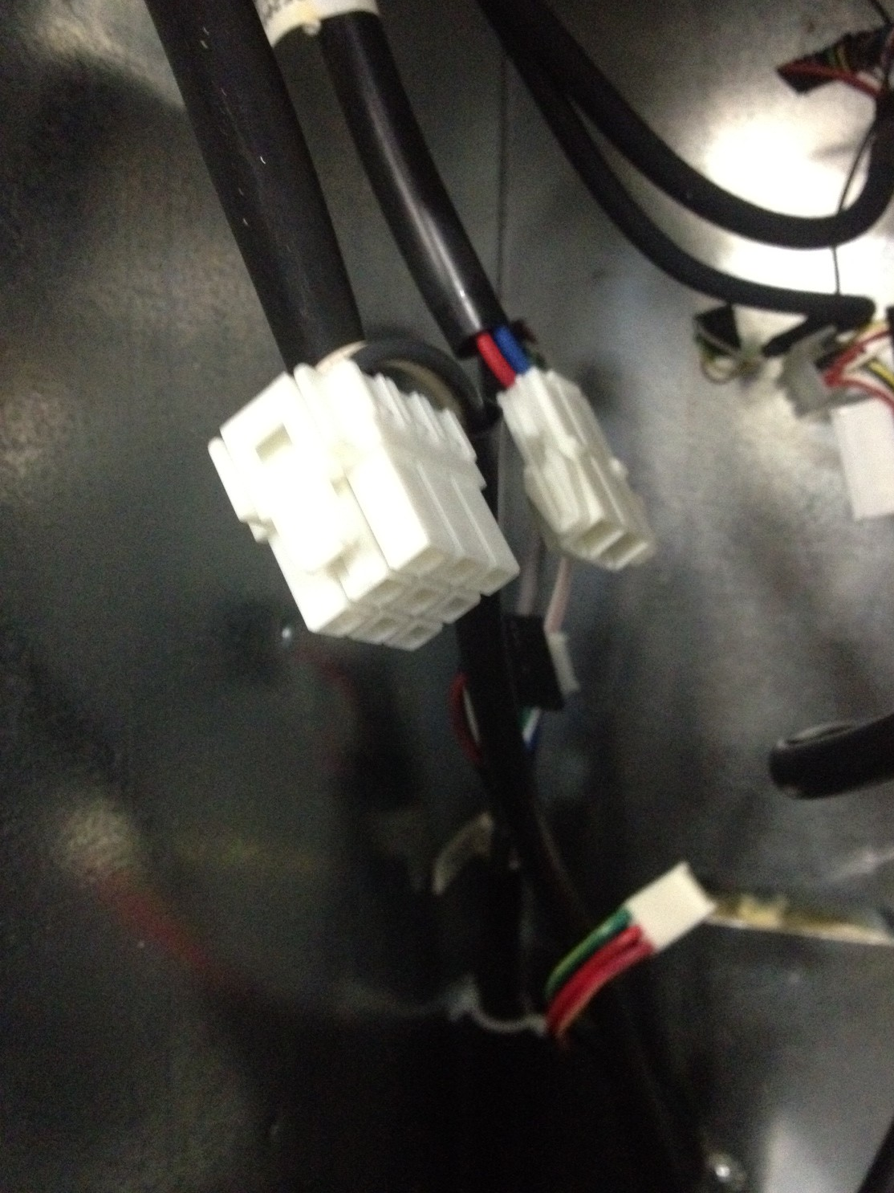

3. Unplug the 2 plugs that are coming out of the ballast's that go to the lights.
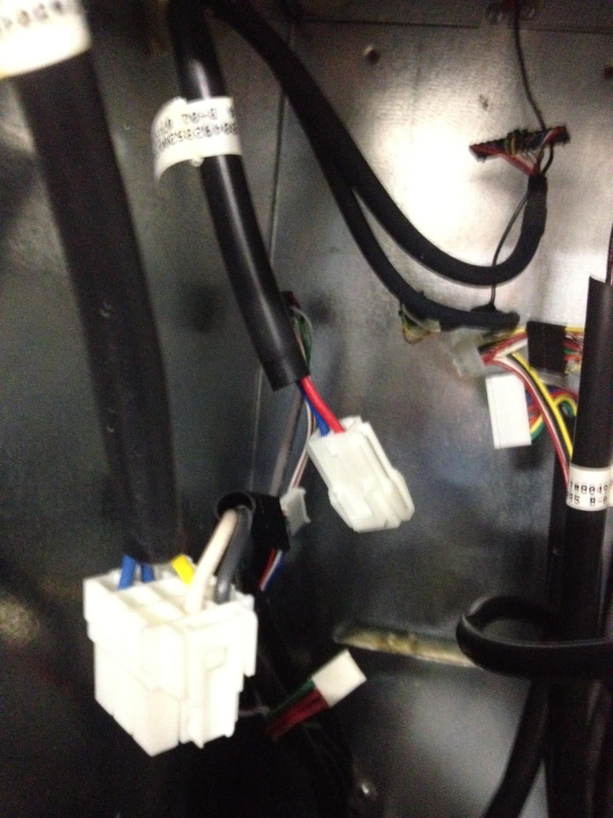

4. Cut the 3 blue wires, 1yellow, 1 red, 1 white, and 1 black wire.

5. Connect the 3 blue wires with the black wire using the crimp cap provided.

6. Connect the yellow, red, and white wire together using the crimp cap provided.

7. Replace the original fluorescent bulbs with the LED bulbs provided.

